INTERVIEW QUESTIONS
1.Explain garbage collector in java
2.What is SOLID Principal- SOLID principles help reduce tight coupling, improve testability, and support scalable architecture like microservices.
3.What is JVM Memory Management
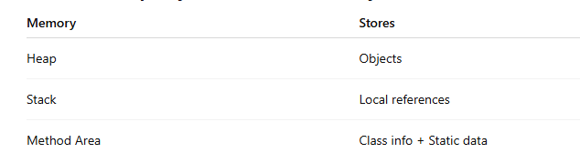
Static method and variable are stored in Method area.
Method Area is a part of JVM memory that stores class-level data such as class metadata, static variables, static methods, and constant pool

4.Stack Overflow vs OutOfMemory Error
5.What is Lazy Evaluation in Java Streams
Java Stream operations don’t run immediately.
They run only when the result is needed. That’s called lazy evaluation.
Java streams have two types of operations:

1️⃣ Intermediate Operations → Lazy (not executed immediately)
Examples:
- filter()
- map()
- sorted()
- distinct()
They just prepare instructions.
stream.filter(x -> x > 10)
👉 Nothing runs yet.

2️⃣ Terminal Operations → Trigger execution
Examples:
- forEach()
- collect()
- count()
- findFirst()
When terminal operation runs → all previous steps execute.
Lazy evaluation in Java Streams means intermediate operations like filter and map are not executed until a terminal operation like collect or forEach is called, which improves performance by avoiding unnecessary computation.

Lazy evaluation improves performance and avoids unnecessary computation.

6. What is intermediate and terminal Operation

7.Is Abstract class and Interface have constructor

Why interface cannot have constructor?
Because:
Constructor is used to initialize object state.
But interface has:
- Interface has no instance variables
- Interface cannot be instantiated
- No object creation → no need of constructor
Abstract class can have constructor because it is used to initialize common properties for subclasses. Abstract class can have instance variable. Even though we cannot create object of abstract class, its constructor is called when a child class object is created.
Constructor runs when child object is created
Parent constructor always executes first

many classes implement interface → why no constructor?
Because:
Each implementing class has its own state and constructor.

The Real Difference (Most Important Idea)
👉 Abstract class itself has its own state
👉 Interface has NO state

8. How to Create Immutable List in Java
1. Using List.of() (Recommended — Java 9+)
👉 Easiest way
List<String> list = List.of("Apple", "Banana", "Mango");
What happens:
- List created
- Cannot modify
If you try:
list.add("Orange");
👉 Throws:
UnsupportedOperationException
✅ 2. Using Collections.unmodifiableList() (Java 8)
👉 Makes an existing list read-only
List<String> temp = new ArrayList<>();
temp.add("Apple");
temp.add("Banana");

List<String> list = Collections.unmodifiableList(temp);
Important:
- You cannot change list
- But original temp can still change
temp.add("Mango"); // list also reflects change
⚠ Not fully immutable — only read-only view.

Basic Usage
import java.util.*;

public class Demo {
public static void main(String[] args) {

List<String> temp = new ArrayList<>();
temp.add("Apple");
temp.add("Banana");

List<String> list = Collections.unmodifiableList(temp);

System.out.println(temp); // [Apple, Banana]
System.out.println(list); // [Apple, Banana]
}
}
Both lists display:
[Apple, Banana]

Example 2: Trying to Modify the Read-only List
list.add("Mango");
Output:
Exception in thread "main"
java.lang.UnsupportedOperationException
Why?
Because list is read-only.

Example 3: Modify the Original List
temp.add("Mango");

System.out.println(temp);
System.out.println(list);
Output:
temp = [Apple, Banana, Mango]
list = [Apple, Banana, Mango]
Why did list change?
Because list is not a separate copy.
It simply points to the same underlying list (temp).

9.How you define a class as immutable in java?
• Declare the class as final
• Make all fields private and final
• Initialize fields only via constructor
• Do not provide setters
• Perform defensive copying for mutable objects like List, Map, or arrays

Why Use Immutable Classes?
- Thread-safe by default
- No synchronization required
3

10. String is immutable in Java, meaning its value cannot be changed after creation.

11.Difference between String Builder and String Buffer
Feature | StringBuilder | StringBuffer
Mutable | ✅ Yes | ✅ Yes
Thread-safe | ❌ No | ✅ Yes
Synchronized | ❌ No | ✅ Yes
Performance | Faster | Slower
Use case | Single thread | Multi-thread
12.Difference between Inheritance and Composition
Inheritance represents an “is-a” relationship where a child class extends a parent class and inherits its behaviour. It creates tight coupling between classes.
Composition represents a “has-a” relationship where one class contains another class as a member, providing better flexibility and loose coupling.

13.Java stream features like stream and lambda improve code readability.
• functional programming style
• less boilerplate
• easier data processing

14.Can you give a real use case where callable is better than runnable?
Callable is preferred over Runnable when a task needs to return a result or throw checked exceptions.
Real Use Case Where Callable is Better
🎯 Scenario: Fetching Data from Database / API
Imagine:
- You send multiple requests to database
- Each task returns result
- You need result after execution

15. How Hash set works internally

internally uses a HashMap to store elements. When we add an element, Java generates a hashcode to find a bucket location and checks for duplicates using equals(). If no duplicate exists, the element is stored. This hashing mechanism makes HashSet fast and ensures unique elements.

What happens if a duplicate element is added?
Short answer:
HashSet ignores the duplicate. It does not throw an exception and does not add the element again.

👉 HashSet internally uses HashMap
But confusion is:
HashMap needs KEY + VALUE
HashSet has only VALUE
So how does it store?

HashSet internally uses a HashMap where the element is stored as the key and a dummy object is stored as the value. Since HashSet only cares about uniqueness, the value is irrelevant and a constant placeholder object is used.
16. What is the difference between monolithic and microservices architecture?
👉 Monolithic architecture is a traditional approach where the entire application is built and deployed as a single unit.
UI + Business logic + Database access → one codebase
Single deployment
All modules tightly coupled
Microservices architecture divides an application into small independent services.
Each service handles one business function
Services communicate via APIs (REST, messaging)
Each service can be deployed independently
✅ 2. Deployment
Monolithic
- Deploy entire application even for small change
- Slower release cycle
Microservices
- Deploy individual service
- Faster releases (CI/CD friendly)

✅ 4. Coupling
Monolithic
Tightly coupled
Microservices
Loosely coupled
✅ 5. Technology Flexibility
Monolithic
- One tech stack mostly
Mxicroservices
- Each service can use different technology

✅ 6. Fault Isolation
Monolithic
- One failure can crash entire system.
Microservices
- Failure isolated to one service.

17. What is Transient Keyword
Do not save this variable when the object is stored or sent.
Why We Use transient
Sometimes we don’t want certain data to be saved, like:
passwords 🔐
temporary data
session data
calculated values
So we mark them transient.

18. Difference between Comparable vs comparator
ALTIMETRIC
19. class Employee {
String name;
String department;
double salary;
}

List<Employee> employees = Arrays.asList(
new Employee("Alice", "IT", 90000),
new Employee("Bob", "IT", 85000),
new Employee("Charlie", "IT", 95000),
new Employee("David", "HR", 70000),
new Employee("Eva", "HR", 75000),
new Employee("Frank", "HR", 72000),
new Employee("Grace", "Finance", 88000),
new Employee("Hannah", "Finance", 92000),
new Employee("Ivy", "Finance", 88000),
new Employee("Jack", "Admin", 60000),
new Employee("Kevin", "Admin", 62000),
new Employee("Laura", "Admin", 61000),
new Employee("Mike", "IT", 95000),
new Employee("Nina", "HR", 75000)
);
print the second highest salary in every department
Map<String, Optional<Double>> result =
employees.stream()
.collect(Collectors.groupingBy(
Employee::getDepartment,
Collectors.mapping(
Employee::getSalary,
Collectors.collectingAndThen(
Collectors.toSet(),
set -> set.stream()
.sorted(Comparator.reverseOrder())
.skip(1)
.findFirst()
)
)
));

result.forEach((dept, salary) ->
System.out.println(dept + " → " + salary.orElse(null)));
20. Default scope of bean -> Singleton
21. Different types of scope in spring boot
Prototype Scope
✔ Meaning
👉 New object created every time requested.
@Scope("prototype")
Request Scope (Web Applications Only)
✔ Meaning
👉 One object per HTTP request.
@Scope(value = WebApplicationContext.SCOPE_REQUEST)
Session Scope (Web Applications Only)
✔ Meaning
👉 One object per user session.
@Scope(value = WebApplicationContext.SCOPE_SESSION)
. Application Scope (Web Applications Only)
✔ Meaning
👉 One object per entire web application.
@Scope(value = WebApplicationContext.SCOPE_APPLICATION)

22. difference between map() and flatMap()
• map() → One input becomes one output
• flatMap() → One input becomes many outputs, then flattened into one
map = transform data
flatMap = transform + flatten
map() is used when each input produces exactly one output, like converting a string to uppercase or getting its length.
flatMap() is used when one input produces multiple values, like a list or array, and we want to flatten them into a single stream.”

23.What is Predicate()
24. Difference between Interface and Abstract class
Abstract class and interface are both used to achieve abstraction in Java.
An abstract class provides partial abstraction — it can have both abstract methods and concrete methods. It can also have instance variables, constructors, and any type of access modifier. Abstract classes support single inheritance only using the extends keyword.
An interface provides a contract for behaviour. It supports multiple inheritance, and a class implements it using the implements keyword. Interfaces cannot have instance variables or constructors — they only allow constants (public static final).
From Java 8 onwards, interfaces can also have default and static methods, so they are not strictly 100% abstract anymore.
Both abstract class and interface cannot be instantiated directly.
25.Which collection we will use if we want to prevent duplicate -> Set or HashSet
26. If set maintains insertion order when elements get added?
❌ No — Set does NOT maintain insertion order by default.
It depends on which Set implementation you use.
1.HashSet → NO order maintained (default) ⭐
2. LinkedHashSet → Maintains insertion order ⭐ Most Asked
✔ Behavior
Maintains insertion order
Uses linked list internally
Slightly slower than HashSet
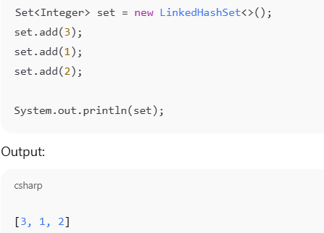
3. TreeSet → Sorted order (not insertion order)
27.What is Collection
28. Implementation of Collection
List Implementation:
ArrayList
LinkedList
Vector
Stack
Set Implementation
HashSet
LinkedHashSet
TreeSet

29. Explain Multithreading concept
👉 Multithreading means running multiple tasks at the same time inside one program.
Instead of doing one job after another, the program does many jobs together.
Without multithreading:
Task 1 → finish → Task 2 → finish → Task 3
With multithreading:
Task 1 + Task 2 + Task 3 run together
30.Explain Thread life cycle
New → Runnable → Running → Waiting → Terminated
1.New -A thread is in the NEW state when it is created but not yet started.

Thread t = new Thread();
Thread object is created
start() is NOT called yet

2.Runnable -> A thread is in the Runnable state when it is ready to run and waiting for CPU time from the thread scheduler.
A thread becomes Runnable when the start() method is called.
3.Running
A thread is in the Running state when it is actively executing its run() method on the CPU.
4) WAITING State
✔ Meaning
👉 Thread is waiting by choice for another thread to do something.
✔ When it happens
- wait()
- join()
5) Terminated
A thread is in the Terminated (Dead) state when its execution is completely finished and it cannot run
again.
Blocked
A thread is in the Blocked state when it is waiting for resources.

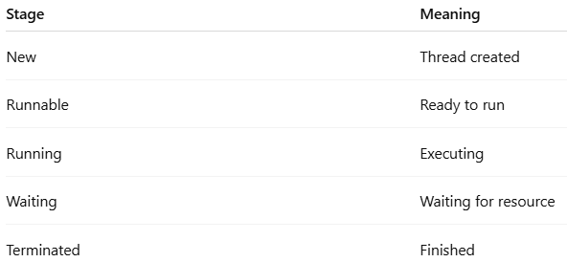31. What is deadlock ?
Deadlock is a situation where two or more threads wait for each other’s resources forever, so none of them can proceed.
• Thread 1 locks Resource A → wants Resource B
• Thread 2 locks Resource B → wants Resource A

32. How to prevent Deadlock?
- Maintain consistent lock ordering across the application
- Use tryLock with timeout instead of synchronized
33.join() method in Thread
The join() method in Java is used when you want one thread to wait for the completion of another thread before it continues its execution.
the current thread (the one that calls join()) will pause and wait until the thread on which join() was called has finished its execution.

33.Write code for Singleton Design pattern?
- Use private static field
- Private constructor
- Public static method
34.How you handle exception globally? Tell how will you implement that?
In Spring Boot, we handle exceptions globally using @ControllerAdvice and @ExceptionHandler. We create a global exception handler class that catches exceptions from all controllers and returns a proper error response. This avoids writing try-catch blocks everywhere and keeps code clean.
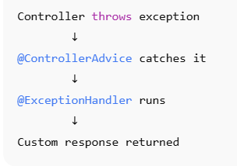
We use global exception handling in a separate class annotated with @ControllerAdvice or @RestControllerAdvice. Inside that class, we define methods using @ExceptionHandler to handle exceptions thrown from controller methods.
35. @Qwalifier in spring boot
36. Spring Port - Spring port is the network port where the Spring Boot application runs, and by default it is 8080. We can change it using the server.port property.

Output
37. List<String> list = Arrays.asList("A", "B", "C");
list.set(1, "X"); //[A,X,C]
list.add("Y"); //Exception
Answer-
⭐ 1️⃣ Arrays.asList("A","B","C")
👉 Creates a fixed-size list backed by array.
["A", "B", "C"]
⚠️ Important:
Size cannot change
Add/remove not allowed
Only modify existing elements allowed
2️⃣ list.set(1, "X") → Works ✅
👉 Replaces element at index 1.
Index: 0 1 2
Before: A B C
After : A X C
Output now:
["A", "X", "C"]
✔ Allowed because size not changing.
⭐ 3️⃣ list.add("Y") → Exception ❌
👉 Arrays.asList() list is fixed size.
You cannot add new elements.
So it throws:
java.lang.UnsupportedOperationException

38. int i = 5;
i = i++ + ++i;
System.out.println(i);
Answer:
i++ → use then increase
++i → increase then use
Dry run:
i-5
i=i++ + ++i now i++=5 used the increase the value of i so i becomes 6
i=6
++i = increase then use . so i becomes i=7
5+7=12

39. String a = "abc";
String b = "ab" + "c";

System.out.println(a == b);

⭐ Step 1:
String a = "abc";
👉 "abc" is stored in string pool.

⭐ Step 2:
String b = "ab" + "c";
👉 "ab" + "c" is a compile-time constant.
Java combines it during compilation:
"ab" + "c" → "abc"
So b also points to the same "abc" in the string pool.

⭐ Step 3: a == b
👉 == compares memory reference, not content.
Since both point to same object:
a == b → true

40. final StringBuilder sb = new StringBuilder("Hello");
sb.append(" World");
System.out.println(sb);
Answer: "Hello World"
final means:
You cannot change the reference (cannot assign new object).
But you can modify the object’s content.

So this is NOT allowed:
sb = new StringBuilder("Hi"); // ❌ error

But this is allowed:
sb.append(" World"); // ✅ allowed

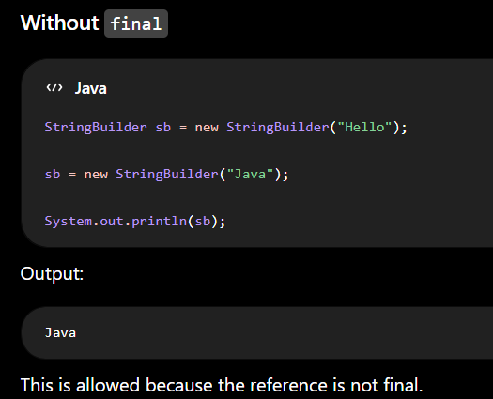

41. Integer a = 128;
Integer b = 128;

System.out.println(a == b); //false

⭐ Integer Caching Concept (Very Important Interview Topic)
Java caches Integer values in range:
-128 to 127
This is called:
Integer Cache

⭐ Case 1 — Value Inside Cache Range (-128 to 127)
Example:
Integer a = 100;
Integer b = 100;
👉 Same object reused → a == b → true

⭐ Case 2 — Value Outside Cache Range (like 128)
Your case:
Integer a = 128;
Integer b = 128;
👉 128 is outside cache range.
So:
a → new object
b → new object
Different memory references.

42. List<String> list = new ArrayList<>();
list.add("A");
list.add("B");
list.add("C");

for (String s : list) {
if (s.equals("B")) {
list.remove(s);
}
}
Answer:
ConcurrentModificationException

43. int x = 10;
int y = 20;

System.out.println(x + y + "Test");
System.out.println("Test" + x + y);
Answer:
30Test
Test1020

Rule to Remember
The + operator works from left to right.
- If both operands are numbers, it performs addition.
- If either operand is a String, it performs String concatenation.

44.String Encoding Problem
Input: "a"
Output: "a1"
Input: "aa"
Output: "a2"
Input: "aabbba"
Output: "a2b3a1"
Input: ""
Output: ""

public class Test {

// Method to encode string using Run Length Encoding
public static String encode(String str) {

// Step 1: Handle null or empty string
// If input is null or empty → return empty output
if (str == null || str.length() == 0)
return "";

// Step 2: Use StringBuilder to store result
// StringBuilder is faster than String for modification
StringBuilder result = new StringBuilder();

// Step 3: Initialize counter for character frequency
int count = 1;

// Step 4: Traverse string from second character
// We compare current char with previous char
for (int i = 1; i < str.length(); i++) {

// Step 5: If current character same as previous → increase count
if (str.charAt(i) == str.charAt(i - 1)) {
count++;
}

// Step 6: If character changes
else {
// Append previous character + count to result
result.append(str.charAt(i - 1)).append(count);

// Reset count for new character
count = 1;
}
}

// Step 7: Add last character and its count
// (Loop ends before adding final group)
result.append(str.charAt(str.length() - 1)).append(count);

// Step 8: Convert StringBuilder to String and return
return result.toString();
}

TCS
--------------------
45.Difference between failFast and failSafe
🔹 1️⃣ Fail-Fast Iterator
✔ Definition
Fail-fast iterators immediately throw ConcurrentModificationException if the collection is structurally modified while iterating.
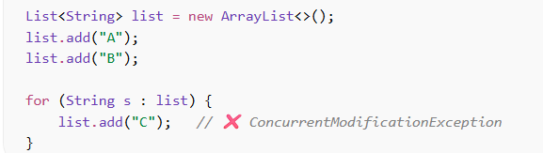
🔹 2️⃣ Fail-Safe Iterator
✔ Definition
Fail-safe iterators do NOT throw ConcurrentModificationException because they operate on a separate copy of the collection.
✔ Common Fail-Safe Collections
- CopyOnWriteArrayList
- ConcurrentHashMap
- CopyOnWriteArraySet

46. How can we use a class itself as a key in a HashMap in Java?
In Java, we can use the class itself as a key in a HashMap by using the Class<?> object as the key.
Every class has a unique Class object, and the Class already implements proper equals() and hashCode(), so we don’t need to override anything.
Eg:-
Map<Class<?>, Object> map = new HashMap<>();
map.put(Student.class, new Student());

? is a wildcard because we don’t know which class type will be stored. It allows storing any class type safely.
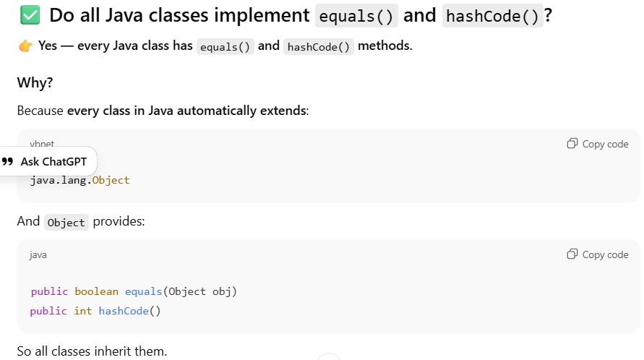

47. What is the difference between throw and throws?
1️⃣ throw → Used to explicitly throw an exception
👉 Purpose: You manually create and throw an exception inside a method.
✅ Key Points
- Used inside method body
- Throws one exception at a time
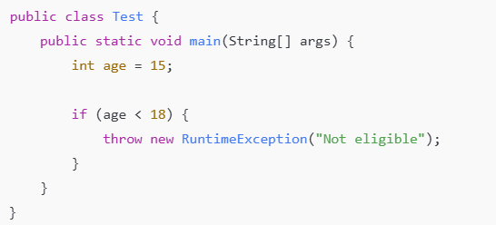
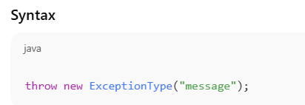

throws → Declares possible exceptions
👉 Purpose: Tell the caller that this method may throw exceptions.
✅ Key Points
- Used in method signature
- Can declare multiple exceptions
- Used mainly for checked exceptions
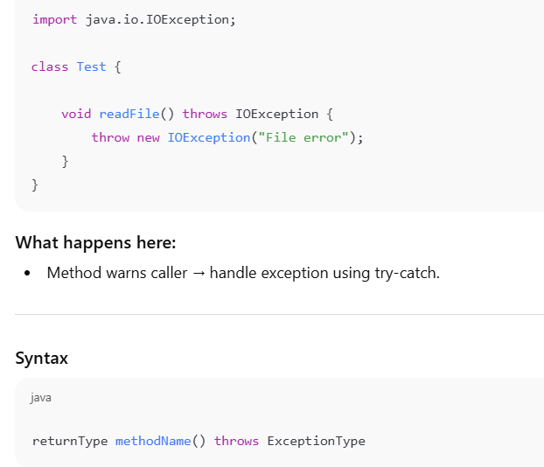
⚠️ Why “caller” matters with throws
When a method uses throws, it says:
"I may throw an exception — whoever calls me must handle it."
So responsibility goes to the caller.

🎯 Main Differences (Interview Ready Table)
Feature | throw | throws
Purpose | Actually throws exception | Declares exception
Used where | Inside method body | Method signature
Number of exceptions | One at a time | Multiple allowed
Followed by | Exception object | Exception class name
Responsibility | Programmer throws | Caller handles
48.What is try block? What is catch block? Explain first, then explain how to implement try block without catch block.
A try block is used to write code that may cause an exception. If an exception happens → control goes to catch or finally.
Eg- try {
int result = 10 / 0; // risky code
}
A catch block handles the exception that occurs inside the try block.
- Executes only if exception happens.
- Prevents program from terminating.

✅ Example
try {
int result = 10 / 0;
} catch (ArithmeticException e) {
System.out.println("Cannot divide by zero");
}
How to implement try block without catch block
try → must have either
catch OR finally OR both
You cannot write:

try {
// code
}
❌ Compile-time error.

The finally block executes whether an exception occurs or not, typically used for cleanup activities.

✅ Scenario You Asked
If try block throws exception
There is NO catch block
Only finally block
Then how is exception handled?

EG-

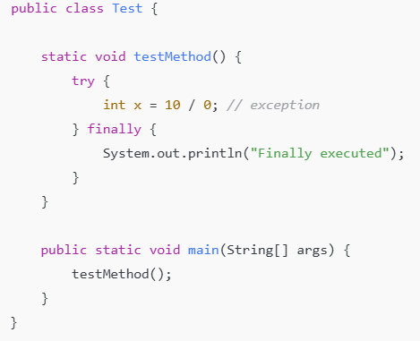

🔥 Execution Flow
Step-by-step:
testMethod() runs
Exception occurs in try
JVM checks → is there catch? ❌ No
JVM executes finally ✅
Exception goes back to caller (main)
If caller doesn’t handle → program crashes

Output
Finally executed
Exception in thread "main" java.lang.ArithmeticException

49. Difference Between Executor.execute() and Executor.submit()
👉 execute() → just runs the task (no result, no tracking)
👉 submit() → runs the task + gives result + tracks status
1️⃣ execute()
👉 What it does:
Executes task in thread pool.
Does NOT return anything.
Cannot track result.
Cannot check task status.
Works with:
Runnable only
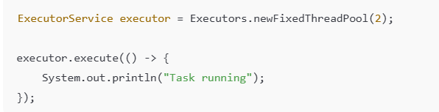

2️⃣ submit() — Run + Get Result
👉 What it does:
- Executes task.
- Returns a Future object.
- Can get result.
- Can check task status.
- Can handle exceptions properly.
- Works with Runnable and Callable.
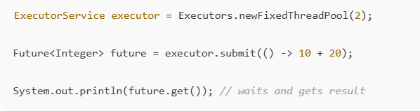

50. Should we store passwords in String or array?
Passwords should be stored in char[] instead of String because String is immutable and remains in memory until garbage collected, while a character array can be cleared after use, making it more secure.
51.Can we catch out of memory error in code using catch block?
Yes, we can catch OutOfMemoryError because it extends Throwable, but it’s not recommended to handle it in business logic.
However, it is not recommended to handle it in normal application logic because it indicates that the JVM is running out of memory and the application is in an unstable state.
👉 Throwable is the parent (superclass) of all errors and exceptions in Java.
52.What is CompletableFuture
CompletableFuture is a class

CompletableFuture implements interfaces:
Future<T>
CompletableFuture is used to run tasks asynchronously and process the result later without blocking the main thread.
(It was introduced in Java 8.)
We can use CompletableFuture by using supplyAsync() method and get the result using thenAccept() method.

Wissen Technology
---------------------------------------
ACID Properties in Java
ACID properties ensure database transactions are safe and reliable.
👉 Transaction = group of database operations treated as one unit.
Example: Bank transfer (deduct + add money).
1️⃣ Atomicity
✅ Definition
Atomicity means a transaction should either complete fully or fail completely.
There is no partial execution.
👉 All operations succeed OR everything is rolled back.

✅ Example
Bank Transfer:
You transfer ₹100 from Account A → Account B.
Steps:
- Deduct ₹100 from A
- Add ₹100 to B
If step 2 fails → step 1 is cancelled.
✔ Money goes back to A.
👉 No half work allowed.

2️⃣ Consistency
✅ Definition
Consistency means database data must always follow rules and remain valid before and after a transaction.
👉 Data should always be correct.

✅ Example
Database rule:
Bank balance cannot be negative.
If transaction tries:
Balance = 500
Withdraw = 600
❌ Transaction rejected.
✔ Database keeps valid data only.
👉 Rules never break.

3️⃣ Isolation
✅ Definition
Isolation means multiple transactions running at the same time should not interfere with each other.
👉 Each transaction works independently.

✅ Example
Two users booking last movie ticket at same time:
- User1 booking
- User2 booking
Without isolation → both get ticket ❌
With isolation → only one gets ticket ✔
👉 Transactions don’t disturb each other.

4️⃣ Durability
✅ Definition
Durability means once a transaction is committed, the data is permanently saved.
👉 Even system crash cannot remove it.

✅ Example
You transfer money → system crashes immediately.
After restart:
✔ Transfer still saved.
👉 Data stays forever.

1️⃣ Commit in Transaction
✅ Definition
Commit means permanently saving all changes made in a transaction to the database.
👉 Once committed:
- Changes cannot be undone
- Data is permanently stored

✅ Example
Bank Transfer
You transfer ₹100 from Account A → Account B.
Steps:
- ₹100 deducted from A ✅
- ₹100 added to B ✅
- Transaction successful → COMMIT
✔ Money updated permanently.
Even if system crashes → changes remain.

✅ 2️⃣ Rollback in Transaction
✅ Definition
Rollback means cancelling all changes made in a transaction and restoring previous state.
👉 If any step fails → undo everything.

✅ Example
Bank Transfer
You transfer ₹100 from Account A → Account B.
Steps:
₹100 deducted from A ✅
System error while adding to B ❌
👉 Database performs ROLLBACK
✔ Money returned to A
✔ No change saved

What is JIT
JIT (Just-In-Time compiler) is a part of JVM that makes Java programs run faster by converting bytecode into machine code at runtime.

What is Records in java

Record is a special immutable data class in Java that automatically generates fields, constructor, getters, equals, hashCode, and toString, reducing boilerplate code.

⭐ When to Use Record
Use record when:
✔ Only storing data
✔ Object should be immutable

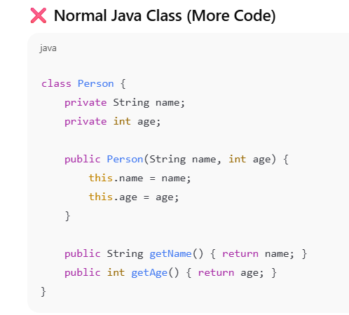++
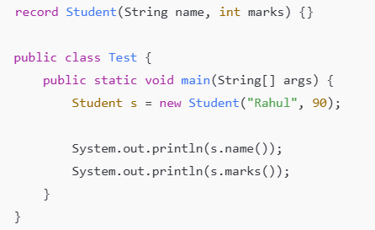

👉 Record can store any type — int, double, object, etc.
The important thing is the record object itself is immutable, not the type.
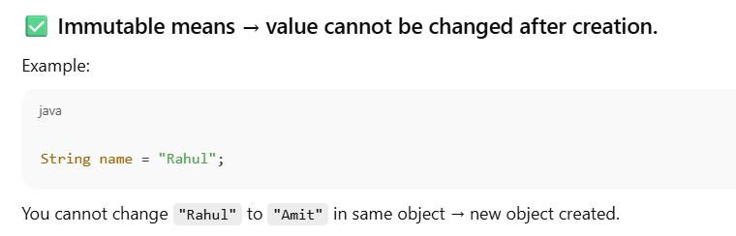
✅ What Makes Record Immutable?
It is because:
Fields in record = final
Final means:
Value cannot be reassigned after object creation.

String a = "hii";
String b = "Ashmita";
String c = "hii" + "Ashmita";
String d = a + b;
We need to find:

✅ How many objects created
✅ Where stored (memory)

1️⃣ String a = "hii";
- "hii" stored in String Constant Pool
- a points to it
Objects created:
1 object → "hii" (SCP)

2️⃣ String b = "Ashmita";
- "Ashmita" stored in String Constant Pool
- b points to it
Objects created:
1 object → "Ashmita" (SCP)
Total so far = 2 objects

3️⃣ String c = "hii" + "Ashmita";
👉 Both are literals → Java joins them at compile time.
Compiler converts to:
String c = "hiiAshmita";
- "hiiAshmita" stored in String Constant Pool
Objects created:
1 object → "hiiAshmita" (SCP)
Total so far = 3 objects

literal + literal → compile time
variable + variable → runtime (StringBuilder used)

- String d = a + b;

Java internally does:
String d = new StringBuilder()
.append(a)
.append(b)
.toString();

2 objects is created in HEAP memory.
Because two different things are created:
- StringBuilder object
- New String object
- Java internally does:
- new StringBuilder().append(a).append(b).toString();
Two objects are created because new StringBuilder() creates one object and toString()

"hii" + "Ashmita" is evaluated at compile time because both are constants. But a + b cannot be evaluated at compile time because the compiler doesn't know the values of variables, so concatenation happens at runtime using StringBuilder.`

Total Object – 5

What are new features introduced in java 8 explain?

What is the difference between interface and functional interface?

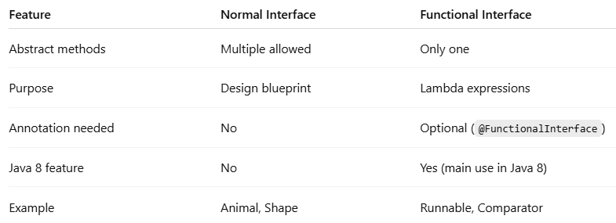

Use cases of default methods
- Add new functionality to existing interfaces without breaking old implementations.
Static methods belong to the interface itself and are used for utility or helper operations related to the interface. They are called using the interface name and cannot be overridden or inherited by implementing classes.

SQL QUERY

Find the second highest salary in an employee table. What if there are duplicate salaries also in the employee table?

SELECT DISTINCT salary
FROM Employee
ORDER BY salary DESC
LIMIT 1 OFFSET 1;

✅ 4. LIMIT 1
What it does:
- Returns only 1 row.
We want only one result → the second highest salary.
- ✅ 5. OFFSET 1
- What it does:
- Skips the first row.
Since sorted descending:
Row 1 → Highest salary (skip)
Row 2 → Second highest salary (return)

Scenario-Based Spring Question

You have a Spring application with the following setup:
- A Controller calls a Service class.
- The Service class contains two Spring beans:
  - One bean with prototype scope
  - One bean with request scope
Inside a service method, the beans are accessed in the following order:
1. Prototype bean
2. Request-scoped bean
3. Prototype bean again
Now assume:
- Two HTTP requests come into the application.
- For each request, the same service method is executed.
❓ Question:
How many total bean instances will be created for:
- Prototype scope bean
- Request scope bean

⭐ 1. Prototype Scope
Rule:
Every time you request it → new object created.
2.quest Scope
    - Rule:
One bean per HTTP request.

🔥 Execution for One Request
Method execution order:
prototype → request → prototype

✅ Step 1 — Prototype bean called
- Prototype always creates new object.
Prototype count = 1

✅ Step 2 — Request bean called
- First time in this request → new object created.
- Same request → reused later.
Request count = 1

✅ Step 3 — Prototype bean called again
- Prototype always creates new object.
Prototype count = 2

✅ Total for ONE request
Prototype beans = 2
Request beans = 1

🚀 Now for TWO HTTP Requests
Spring repeats the same behavior for each request.

✅ Prototype Beans
2 per request × 2 requests = 4

✅ Request Beans
1 per request × 2 requests = 2

✅ ✅ Final Answer
Prototype beans created = 4
Request beans created = 2

Common Questions On React JS
In React, a component re-renders when React thinks something changed.
Interviewer asks: "H“w do you prevent unnecessary re-renders?"
”our answer: "U“e React.memo() to skip re-renders when props don't’change, and useCallback() meemorizedunctions."
” Wrap child components with React.memo()
✅ Wrap functions with useCallback()
✅ Check the dependency array (what should trigger changes?)
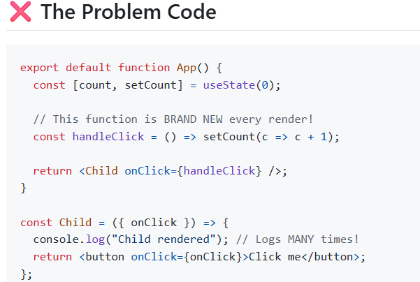

What happens:

- App renders once
- A NEW handleClick function is created
- Child gets a different onClick prop (new function reference)
- React thinks: "T“e prop changed!" ” Re-renders Child
- A NEW handleClick function is created again
- Infinite loop! 🔄

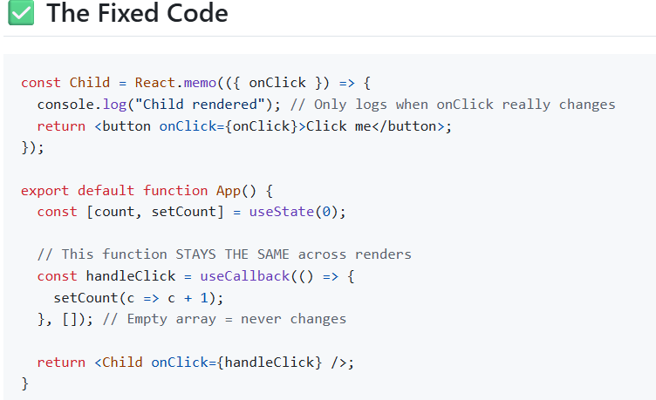
👉 useCallback remembers the function (not the dependency), and it decides whether to recreate the function based on the dependency array.
⭐ Simple Rule
Dependency changes → new callback created
Dependency same → same callback reused
🎯 Example to Make It Clear
Case 1 — Dependency changes
const fn = useCallback(() => {
console.log(count);
}, [count]);
What happens:
count = 0 → function created
count = 1 → dependency changed → new function created
count = 2 → new function again

Case 2 — Dependency does not change
const fn = useCallback(() => {
console.log("h“llo")”
}, []);
What happens:
First render → function created
Next render → same function reused
Always same function

setCount(c => c + 1)
- c is provided by React automatically
- It is NOT your variable
- It is NOT tracked by useCallback
- It is NOT in dependency array
So React says:
Function does not depend on external value → keep same function

⭐ Interview-Level One Line Answer
Even though state changes, the callback is not recreated because it does not depend on count, and the dependency array is empty, so React reuses the same function.
Interviewer asks: "Why should not you use index as a key?"
We should not use index in React lists because when the list changes (items added, removed, or reordered), the index also changes. It make wrong ui updates.
Eg-
Before: A B C (index: 0 1 2)
Remove A
After: B C (index: 0 1)
👉 React thinks:
- B was A
- C was B
→ wrong updates.
Keys are used in React Lists to uniquely identify elements. During reconciliation react uses keys to understand which item has changed, added or removed.
Eg- const students = [
{ id: 1, name: "R“hul" ”,
{ id: 2, name: "P“iya" ”,
{ id: 3, name: "A“it" ”
];
students.map(student => (
<li key={student.id}>{student.name}</li>
));

🟢 Now remove Rahul
id 2 → Priya (same person)
id 3 → Amit (same person)
👉 React knows exactly who was removed.

Why is mutating state bad in React?
They are asking:
👉 Why shouldn’t we directly change state value?
👉 Why must we use setState / setCount instead?

👉 React will not detect the change properly.
👉 So UI may not update or may behave incorrectly.
Because React checks:
Did the state reference change?
If reference is same → React thinks nothing changed → no re-render.

🧠 Simple Idea
Direct change → React unaware
Setter function → React aware

React does not recommend mutating state directly because React relies on state updates to detect changes and trigger re-rendering. If we modify state directly, React may not detect the change because the state reference remains the same. This can cause the UI not to update correctly and lead to unpredictable bugs. That’s why we should always update state using setter functions like setState or useState.
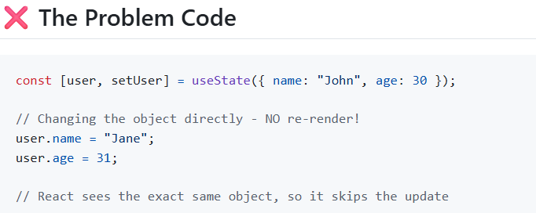
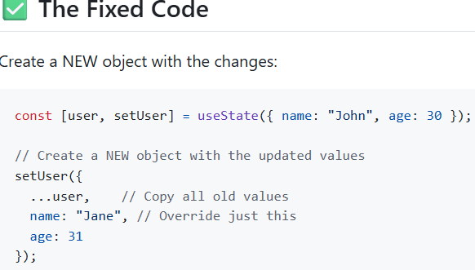
What happens: React compares:
- Old object: { name: "J“hn",”age: 30 }
- New object: { name: "J“ne",”age: 31 }
- They'r’ different! → Update the UI ✅
Interviewer asks: "What should you put in the dependency array?"
”Empty [] array – Runs only once in first render
If we use value inside dependency array
[dependency1, dependency2] – Runs when the value changes
If no dependency array – runs on every render

Interviewer asks: "How do you prevent Context from causing unnecessary re-renders?"
”1.lit context
2. Memoize provider value using useMemo
3. Use React.memo in Consumer components
Context can cause unnecessary re-renders because when its value changes, all consuming components re-render. We can prevent this by splitting context into smaller contexts, meemorizedhe provider value using useMemo, and using React.memo in Consumer components

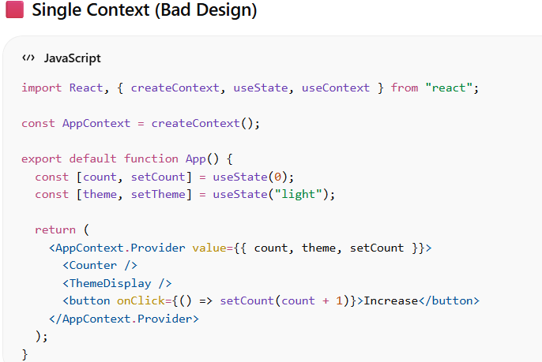
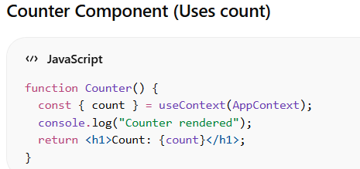
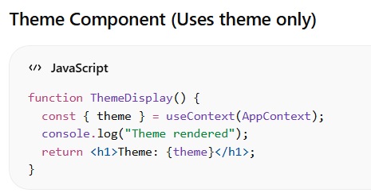
❗ Problem
When clicking button:
Counter rendered ✔ (needed)
Theme rendered ❌ (not needed)
👉 Because entire context value changed.

FIXED CODE
import React, {
createContext,
useState,
useContext,
useMemo
} from "r“act";”
const CountContext = createContext();
const ThemeContext = createContext();

export default function App() {
const [count, setCount] = useState(0);
const [theme] = useState("l“ght")”

// meemorizedalue (only changes when count changes)
const countValue = useMemo(() => ({ count, setCount }), [count]);

return (
<ThemeContext.Provider value={theme}>
<CountContext.Provider value={countValue}>
<Counter />
<ThemeDisplay />
<button onClick={() => setCount(count + 1)}>Increase</button>
</CountContext.Provider>
</ThemeContext.Provider>
);
}
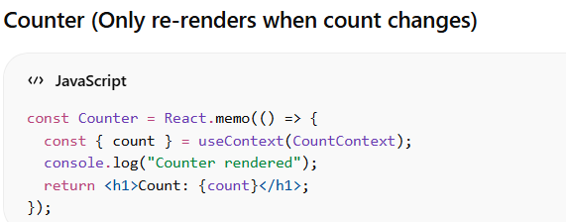
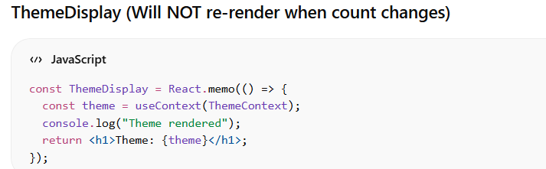

Interviewer asks: "Why can't you use hooks inside conditions?"
Hooks cannot be used inside conditions because React relies on the order of hook calls to manage state. If hooks are called conditionally, the order may change between renders, which can cause bugs and incorrect state behaviour.

Interviewer asks: "How would you handle rendering 10,000 items?"
”We can use Virtualization.
It only render the items visible on the screen.
Common library:
react-window
React-virtualization
Implementation:
npm install react-window
Import {FixedSizeList as List} from react-window
Implement the virtualised list to be displayed on screen

Interviewer asks: "What does that warning mean: 'Can't perform a React state update on an unmounted component'?’
”"I“ means an async operation like an API call, timer, or subscription is trying to update state after the component has been removed from the DOM. React warns because it can cause memory leaks. We fix it using cleanup functions in useEffect or by caemorizedsync operations."
”A cleanup function is a function returned from useEffect that runs when a component unmounts or before the effect runs again. It is used to stop side effects like API calls, timers, or subscriptions to prevent memory leaks.
✅ It cleans background work when component is removed.
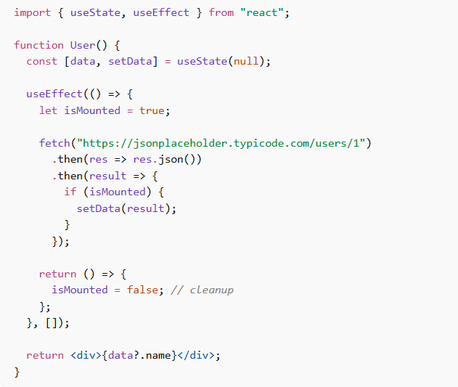
Interviewer asks: "Should you always use useMemo and useCallback?"
”Your answer: "N“. These have a cost, so only use them when you'v’ measured and confirmed the component is actually slow. Generally:
- Use useMemo for expensive calculations (like sorting large arrays)
- Use useCallback to prevent re-renders of memorized child components

"What is the difference between useRef and useState? When would you use each?"
”use useState when updating data affects UI and should trigger re-render, like form inputs or API data. I use useRef when I need to store values or access DOM elements without causing re-renders, like storing timers, previous values, or focusing inputs

Interviewer asks: "What are Error Boundaries? Why do we need them?"
”One component throws an error → entire app crashes and goes white.
Users see a blank screen instead of just broken component.
What Are Error Boundaries?
Error Boundaries are class components that catch JavaScript errors in child components.
Think of them like try-catch blocks for React.

When a component errors, instead of a blank white screen, Error Boundary shows a fallback UI. This is important for user experience.

Birla Software
List<Employee>
salary
id
name
department
Find highest salary in each department
Map<String, Optional<Employee>> result =
employees.stream()
.collect(Collectors.groupingBy(
Employee::getDepartment,
Collectors.maxBy(
Comparator.comparingDouble(Employee::getSalary)
)
));
result.forEach((dept, empOpt) ->
System.out.println(dept + " “> " “ empOpt.get().getSalary())
);

✅ Output (Example)
IT -> 70000.0
HR -> 80000.0
Finance -> 65000.0
Way 1 — Using distinct() (No Set, Simple)
👉 Department → Highest distinct salary
Map<String, Optional<Double>> result =
employees.stream()
.collect(Collectors.groupingBy(
Employee::getDepartment,
Collectors.collectingAndThen(
Collectors.mapping(Employee::getSalary, Collectors.toList()),
list -> list.stream()
.distinct() // remove duplicate salaries
.max(Double::compare) // find highest
)
));
result.forEach((dept, salaryOpt) ->
System.out.println(dept + " “> " “ salaryOpt.get())
);

✅ Second Highest Salary in Each Department (Stream Way)
⭐ Return → Department → Second Highest Salary
Map<String, Optional<Double>> result =
employees.stream()
.collect(Collectors.groupingBy(
Employee::getDepartment,
Collectors.collectingAndThen(
Collectors.mapping(Employee::getSalary, Collectors.toList()),
list -> list.stream()
.distinct() // remove duplicate salaries
.sorted(Comparator.reverseOrder()) // highest first
.skip(1) // skip highest
.findFirst() // second highest
)
));

✅ Print Department + Second Highest Salary
result.forEach((dept, salaryOpt) ->
System.out.println(
dept + " “> " “ salaryOpt.orElse(0.0)
)
);

What is Prop drilling ? How will you prevent it ->Prevent using Context API
Circuit breaker implementation
Properties:
resilience4j.circuitbreaker.instances.userService.failure-rate-threshold=50
resilience4j.circuitbreaker.instances.userService.sliding-window-size=10
resilience4j.circuitbreaker.instances.userService.wait-duration-in-open-state=10s
resilience4j.circuitbreaker.instances.userService.permitted-number-of-calls-in-half-open-state=3
Main Annotation
On Service Method
@CircuitBreaker(name = "u“erService",”fallbackMethod = "f“llbackResponse")”
👉 fallbackMethod → runs when failure happens
Dependency:
✅ Resilience4j starter → main library
✅ Spring Boot AOP → required for annotations
✅ Spring Boot Actuator (optional but recommended) → monitoring

N+1 program
The N+1 problem occurs when an application executes one query to fetch parent data and then executes N additional queries to fetch related data, causing performance issues.
👉 Too many database calls.
1 query → fetch main data
N queries → fetch related data
Total → N + 1 queries
✅ Your Scenario
You have:
Department table
dept_id | name
p;.’;1 | IT
2 | HR
👉 2 departments

Employee table
Department 1 → 10 employees
Department 2 → 20 employees
👉 Total 30 employees.

✅ Case 1 — Without Fetch Join (Lazy Loading → N+1 Problem)
Step-by-step what happens:
✅ Query 1 — Fetch all departments
SELECT * FROM department;
👉 Returns:
Department 1
Department 2
Queries so far = 1

✅ Query 2 — Fetch employees for department 1
SELECT * FROM employee WHERE dept_id = 1;
Queries so far = 2

✅ Query 3 — Fetch employees for department 2
SELECT * FROM employee WHERE dept_id = 2;
Queries so far = 3

⭐ Total Queries
1 (departments) + 2 (for each department employees)
= 3 queries

How to Resolve this N+1 problem
With Fetch Join
@Query("SELECT d FROM Department d JOIN FETCH d.employees")
Change Fetch Type (LAZY → EAGER)
Example
@OneToMany(fetch = FetchType.EAGER)
private List<Employee> employees;
What happens:
- Loads related data automatically.
What shall we use in use effect hook so that it renders only once -> Empty dependency array
shall we update state inside useEffect hook
what is @entity
The class is mapped to a table in database. Fields of the class are the column name of the table.
We use @Id to define the primary key and @GeneratedValue to automatically generate the ID value.

Difference between @controller and @Restcontroller
StringBuilder vs String Buffer
Both StringBuilder and String Buffer are used to create mutable strings. The main difference is that String Buffer is synchronized and thread-safe, while StringBuilder is not synchronized and not thread-safe. Because of synchronization, String Buffer is slower(Because it is thread safe , one task need to wait until another is using the shared resource to complete the task) but safe for multi-threaded environments, whereas StringBuilder is faster and used in single-threaded scenarios.
what do you mean by thread safe
Thread-safe means multiple threads can use the same shared resource at the same time without causing errors or inconsistent results.
One way to achieve thread safety in Java is using the synchronized keyword, which allows only one thread to access a shared resource at a time while others wait."

What is race conditions?
A race condition happens when multiple threads access and modify shared data at the same time and the final result depends on which thread runs first, causing unpredictable or incorrect results.

Real-Life Example (Easy to Explain in Interview)
- Bank balance = ₹1000
- Two ATM withdrawals at same time
- Both read ₹1000

- Both deduct ₹500
- Wrong balance
👉 Race condition.

What is default method
✅ Default methods introduced in Java 8 → correct
✅ They have a method body → correct
✅ Child classes don’t need to implement them → correct
✅ Helps add new features without breaking existing code → very important and correct
"If an interface has many implementing classes and we want to add a new method, instead of forcing all classes to implement it, we provide a default implementation in the interface. Classes can use it or override it if needed."
Scenario Based
There are 2 interfaces one child class implement both the interface
in the interface 2 default method are there both are same default method
which default method child class will call

👉 Java gets confused → ambiguity (diamond problem).

How To Prevent this?

subclass must override it and provide its own implementation to resolve ambiguity

Step 1 — Interface 1
interface Interface1 {
default void show() {
System.out.println("Interface1 show()");
}
}

Step 2 — Interface 2
interface Interface2 {
default void show() {
System.out.println("Interface2 show()");
}
}
👉 Both interfaces have same method → conflict.

Step 3 — Subclass Resolves by Overriding
class Test implements Interface1, Interface2 {
// must override to remove ambiguity
@Override
public void show() {
System.out.println("My own implementation in Test class");
}
public static void main(String[] args) {
Test t = new Test();
t.show();
}
}

✅ Output
My own implementation in Test class

specific interface method
InterfaceName.super.methodName();
Step 1 — Interface 1
interface Interface1 {
default void show() {
System.out.println("Interface1 show()");
}
}

Step 2 — Interface 2
interface Interface2 {
default void show() {
System.out.println("Interface2 show()");
}
}

Step 3 — Class Implementing Both (Must Override)
class Test implements Interface1, Interface2 {
@Override
public void show() {
// choose Interface1 method
Interface1.super.show();
// OR choose Interface2 method
// Interface2.super.show();
// OR provide own implementation
System.out.println("My own implementation");
}
public static void main(String[] args) {
Test t = new Test();
t.show();
}
}

Can we update state inside useEffect Hook?
Yes, we can update state inside useEffect. But we must be careful because updating state causes a re-render, and useEffect runs after every render. If we update state without proper dependency control, it can create an infinite re-render loop. That’s why we use the dependency array to control when the effect runs.

UST Global
Write program for Multithreading
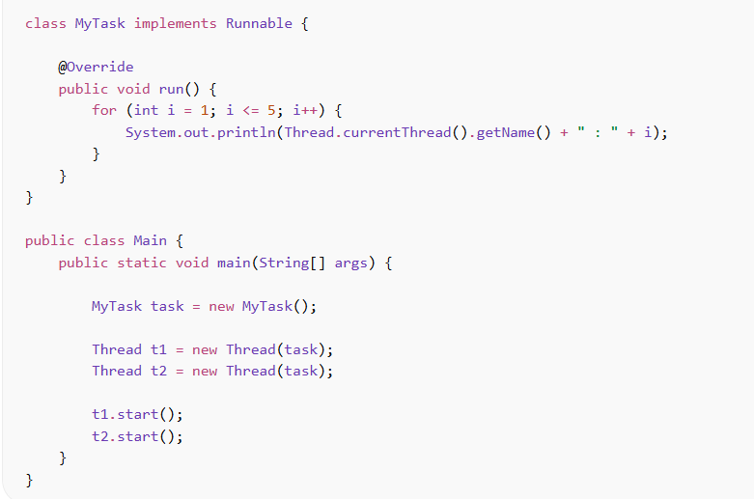
Why we prefer to create thread by implementing Runnable Interface?
Java does NOT support multiple inheritance
If you extend Thread:
class MyTask extends Thread
👉 Your class cannot extend any other class.
👉 What if your class already needs to extend another class?
Then you cannot extend Thread.

Explain OOPs concept in java
Java follows 4 main OOP principles: Encapsulation, Abstraction, Inheritance, and Polymorphism.

How is Polymorphism achieved in java
Compile-time polymorphism is achieved using method overloading, where the method behaviour is decided at compile time by the compiler.
Runtime polymorphism is achieved using method overriding, where the method call is resolved at runtime by the JVM based on the object.

What is Normalization
👉 Normalization is the process of organizing data in database tables to remove duplicate data and avoid data problems.

1NF, 2NF, 3NF

1NF → Remove repeating columns
👉 Each column must have single (atomic) value.
👉 No multiple values in one cell.
2NF → Remove partial dependency
3NF → Remove indirect dependency

Write a program for document parser in Java using polymorphism. (For xml, json etc documents)
⭐ Parent Class
class DocumentParser {
void parse(String data) {
System.out.println("Parsing generic document");
}
}

⭐ XML Parser (Override)
class XMLParser extends DocumentParser {
@Override
void parse(String data) {
System.out.println("Parsing XML document: " + data);
}
}

⭐ JSON Parser (Override)
class JSONParser extends DocumentParser {
@Override
void parse(String data) {
System.out.println("Parsing JSON document: " + data);
}
}

⭐ Main Class — Parent Reference + new Keyword (Real Polymorphism)
public class ParserDemo {
public static void main(String[] args) {
// Parent reference + child object
DocumentParser parser = new XMLParser();
parser.parse("<user>Abhi</user>");
// Same reference → different object
parser = new JSONParser();
parser.parse("{name: Abhi}");
}
}

✅ Output
Parsing XML document: <user>Abhi</user>
Parsing JSON document: {name: Abhi}

What is document class?
A Document class is a Java class annotated with:
@Document
It tells Spring Boot:
👉 “Store objects of this class inside a MongoDB collection.”
Define factory pattern
The Factory Pattern is a creational design pattern that provides a way to create objects without exposing the object creation logic to the client.
👉 Instead of using new directly, we use a factory method to create objects.
👉 Factory Pattern = Object creation through method instead of new.
EG:-
Step 1: Create Interface
interface Shape {
void draw();
}

Step 2: Create Implementations
class Circle implements Shape {
public void draw() {
System.out.println("Drawing Circle");
}
}
class Rectangle implements Shape {
public void draw() {
System.out.println("Drawing Rectangle");
}
}

Step 3: Create Factory Class
class ShapeFactory {
public static Shape getShape(String type) {
if(type.equalsIgnoreCase("circle"))
return new Circle();
else if(type.equalsIgnoreCase("rectangle"))
return new Rectangle();
return null;
}
}
👉 Object creation logic is here.

Step 4: Client Code
public class Main {
public static void main(String[] args) {
Shape s = ShapeFactory.getShape("circle");
s.draw();
}
}
What is HashMap?
HashMap is a class in Java that implements the Map interface and stores data in key–value pairs.
Internal working of HashMap in Java
On what factors do we decide which collection to choose while working on a project?
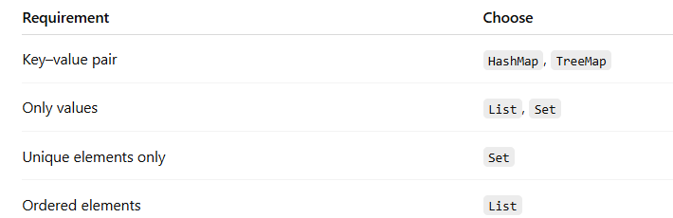
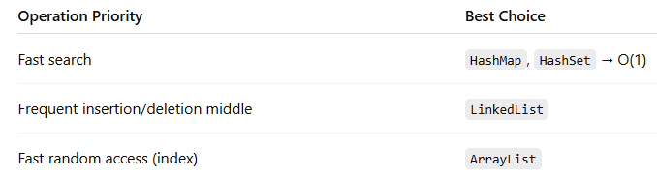
What is linked list?
A linked list is a linear data structure where elements are stored in nodes, and each node contains data and a reference to the next node.
Singly Linked List EG:-
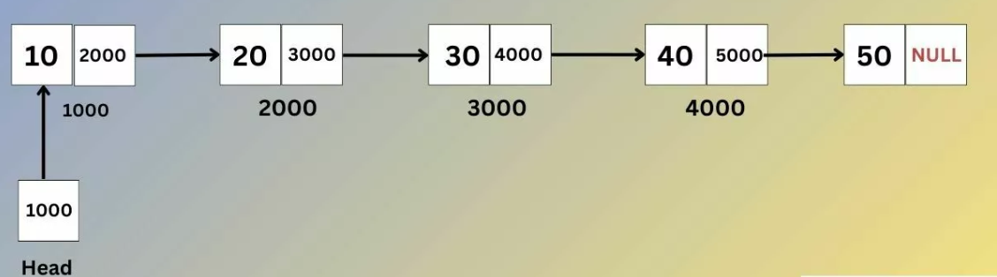
Why is linked list called a dynamic data structure?
A linked list is called a dynamic data structure because memory is allocated at runtime, and its size can increase or decrease as elements are added or removed. Size is not fixed.
What is a linear data structure?
A linear data structure is a data structure in which elements are stored sequentially, and each element is connected to its previous and next element.
Give example of linear and non linear data structures.
⭐ Examples of Linear Data Structures - ✔ Array, ✔ Linked List, Array List
⭐ Examples of Non-Linear Data Structures-Tree, Graph, Hash Set, Hash Map
Is HashMap linear or non linear? –> Non Linear

Write a multithreading program using scanner module and display module.
import java.util.Scanner;

// Display class implementing Runnable
class Display implements Runnable {

String message;

// Constructor
Display(String message) {
this.message = message;
}

// Task to run in thread
public void run() {
System.out.println("Displaying from thread: " + message);
}
}

// Main class
public class MultiThreadRunnableExample {

public static void main(String[] args) {

Scanner sc = new Scanner(System.in);

System.out.print("Enter a message: ");
String msg = sc.nextLine();

// Create Runnable object
Display d = new Display(msg);

// Pass Runnable to Thread
Thread t = new Thread(d);

// Start thread
t.start();

sc.close();
}
}
Microservices vs monolithic architecture.
Is your current project having microservices or is monolithic. Explain the implementation.

Describe architecture of your project with high level diagram
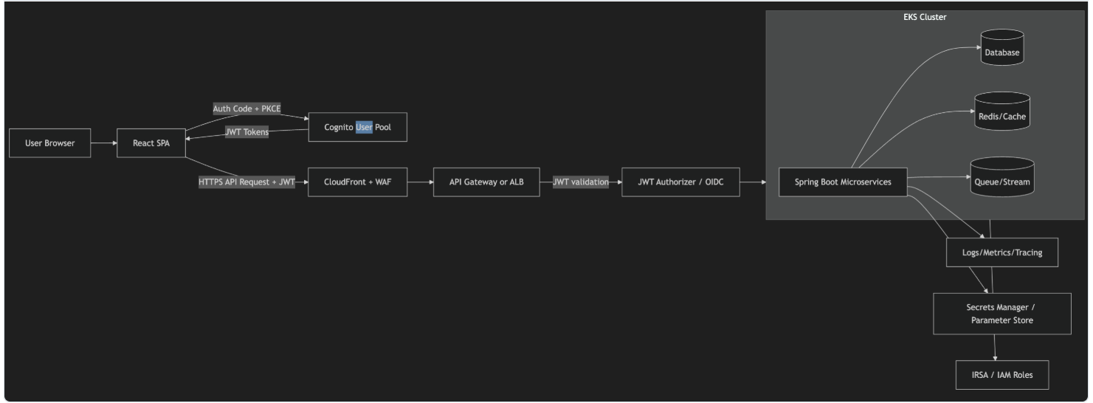
When a user opens the application, the React frontend redirects the user to AWS Cognito for login. Cognito verifies credentials and returns a JWT token. The frontend sends API requests with the JWT in the header. The request first goes through CloudFront and WAF for security and performance, then to API Gateway or load balancer. The JWT is validated, and if authorized, the request reaches Spring Boot microservices running in EKS, which then interact with databases or other backend services.

If the token is invalid or missing, I would normally get a 401. If the token is valid but the user doesn't have the required authority, I would get a 403.

The user's credentials are managed by the Cognito User Pool, which is an AWS-managed user directory.

JWT Authorizer Validates Token (Authentication Check)
Before checking permissions, system verifies:
✔ Token signature valid?
✔ Token expired?
✔ Issued by Cognito?
If invalid → request rejected immediately.

Spring Boot Microservice → Actual Role Check (Authorization) ⭐
After JWT validation:
- Request reaches Spring Boot microservice.
- Spring Security extracts roles from JWT.
- Microservice decides:
👉 “Does this user have permission for this API?”
Example:
@PreAuthorize("hasRole('ADMIN')")
@GetMapping("/employees")
- ADMIN → allowed ✅
- USER → denied ❌

Spring Security extracts role from JWT
- Spring Boot has Spring Security + JWT filter.
- When request comes:
  - Reads JWT from header (Authorization: Bearer token)
  - Decodes token
  - Extracts role/claims (like ADMIN, USER)

User login → Cognito gives JWT with roles
↓
CloudFront / API Gateway
↓
JWT Authorizer → token valid? (authentication)
↓
Spring Boot Microservice → role allowed? (authorization)
↓
Database / response

✔ User logs in → Cognito verifies username/password
✔ Cognito returns JWT token
✔ Frontend sends JWT in header
✔ Request goes through security layers
✔ JWT validated
✔ If authorized → Spring Boot microservice
✔ Microservice → database

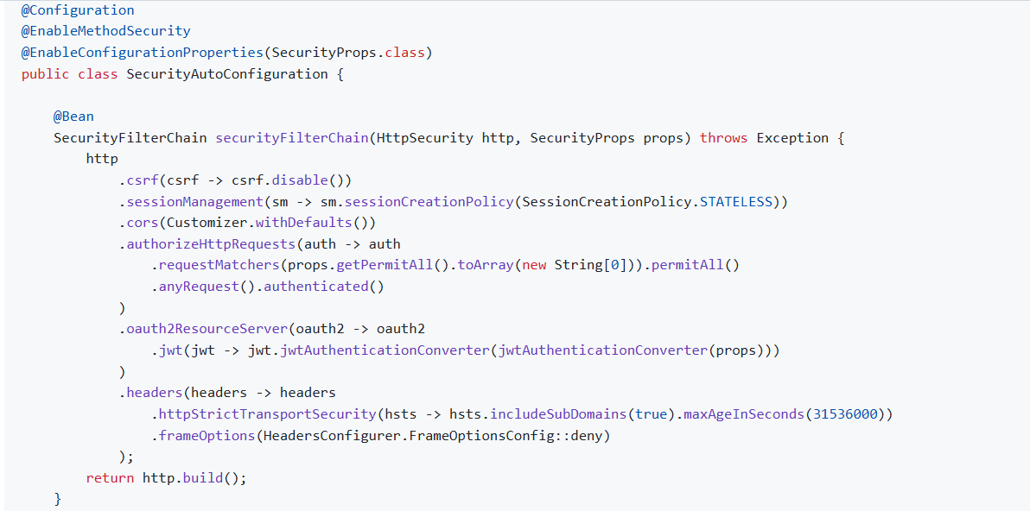

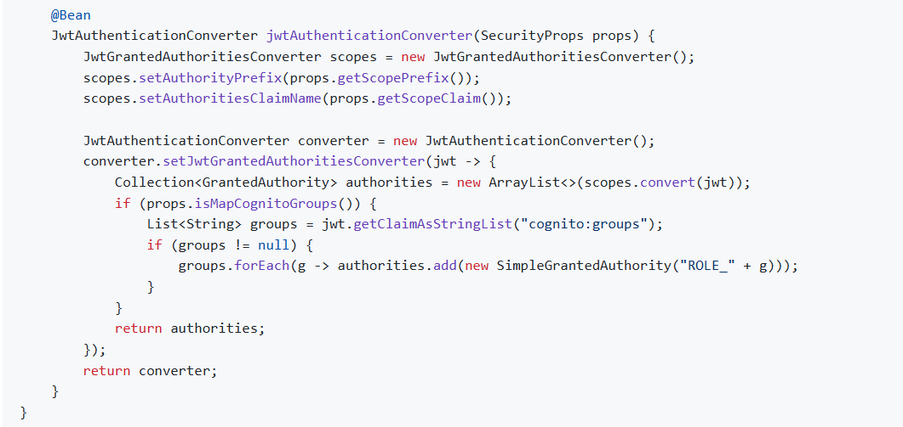

We created a centralized security configuration using @Configuration.
Then:
We enabled method-level authorization using @EnableMethodSecurity, which allows us to use annotations like @PreAuthorize for role-based access.
Then:
We used @EnableConfigurationProperties to load dynamic security settings like public APIs and JWT mapping from application configuration.
Inside the SecurityFilterChain bean, we configure how every request is handled.
1. Stateless Security
We disable:
- CSRF
- Session creation
Because JWT is used.
So:
Every request must bring its own token.
No session stored in backend.

@PreAuthorize("hasRole('ADMIN')")
Spring automatically:
✔ Reads JWT
✔ Extracts roles
✔ Checks permission
If role matches → request allowed
Else → denied

But Then How is it Centralized?
We don’t copy-paste security code.
Instead we create:
👉 A Shared Security Library . Each microservice imports this library
Example:
security-common-lib

What is docker?
What do you understand by containers?

Accolyte
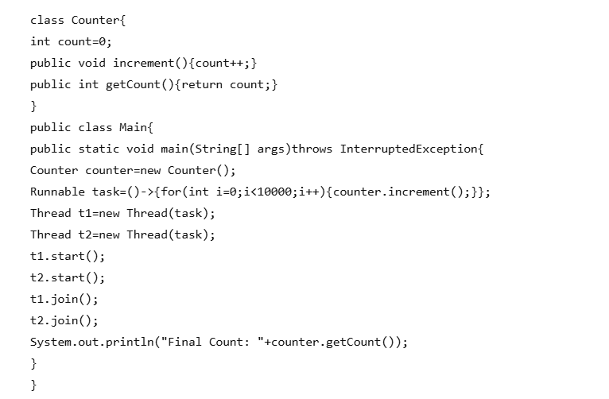

Find the output

output:

👉 Two threads increase the same counter value.
👉 Each thread increments 10,000 times.
👉 Expected output → 20000.
👉 But sometimes you get wrong output (like 15876, 18732 etc).
Why? → Thread safety problem.

t1 and t2 run at same time.
join() only blocks main thread.
Threads don't wait for each other.

Yes ✅ — your program has a race condition because multiple threads update the same variable (count) at the same time.
To fix it → we make increment thread-safe.
There are 2 common solutions:
✅ synchronized (locking)
✅ AtomicInteger (lock-free, faster)

Solution 1: Code Using synchronized

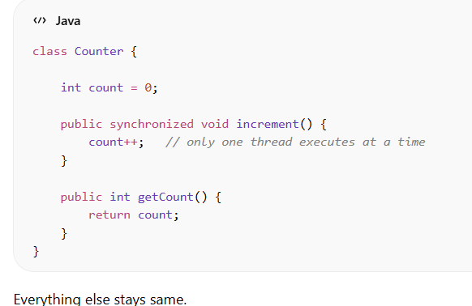

✅ Result
Final Count: 20000 (always correct)

✅ Solution 2 — Using Atomic Integer (Best Modern Way)

AtomicInteger is a thread-safe integer class in Java.
👉 It allows multiple threads to update a number safely without using synchronized.

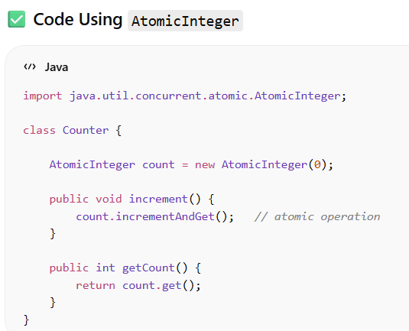

Internal working of synchronised

Thread 1 → gets lock → runs → releases lock
Thread 2 → waits → runs after Thread 1

Internal working of AtomicInteger

Read value → Compare (Compare current value with expected value) → Update if same → else retry

✅ Step 1 — Thread Reads Value
Both threads read:
current value = 5

✅ Step 2 — Thread Tries CAS Operation
CAS means:
Compare current value with expected value.
If same → update.
If not → retry.

Thread 1 Execution
Expected value = 5
Actual value = 5 ✔
So:
Update → 6
Value becomes:
count = 6

Thread 2 Execution
Thread 2 still thinks value is 5:
Expected = 5
Actual = 6 ❌
So:
Update fails
Retry again
Thread 2 reads new value:
6 → update to 7

What is a Transaction?
A transaction is a group of database operations that work as one single unit.
👉 Either everything succeeds → changes saved (commit)
👉 If anything fails → everything is undone (rollback)

💡 Real-life example
Bank transfer:
Deduct ₹1000 from Account A
Add ₹1000 to Account B
If money is deducted but not added → ❌ wrong.
So both must succeed or both cancel → transaction.

Database follow ACID property for using transactions safely and in reliable way.
Atomicity → all or nothing
Consistency → valid data only
Isolation → separate transactions don’t affect each other
Durability → committed data stays

Explain how transactions work internally?
Internal flow:
- Spring creates proxy object.
- Proxy opens database transaction.
- Executes method.
- If success → commit.
- If runtime exception → rollback.

You don’t write commit/rollback manually.

A proxy object is a wrapper around the real object that controls access to it.

Can we use proxy inside private methods
❌ No — Spring proxy does NOT work for private methods.
Only external method calls go through proxy.
Private methods are called directly, not via proxy.
Client → Proxy → public method ✅

There is an employee object. Store that employee object in HashMap. How we can do that?

Suppose employee has:
- id
- name

If you want to store an Employee object as a key in a HashMap, you must do 2 important things:
✅ Override equals()
✅ Override hashCode()
Otherwise HashMap will not work correctly.
hashCode() → to find bucket
equals() → to compare keys

// generate hash
@Override
public int hashCode() {
return Objects.hash(id);
}

// compare objects
@Override
public boolean equals(Object o) {
if (this == o) return true;
if (!(o instanceof Employee)) return false;
Employee e = (Employee) o;
return id == e.id; // compare by id
}
// Step 1: Check if both references point to the same object in memory
// If yes, they are definitely equal
if (this == o) return true;
// Step 2: Check if the passed object is NOT an Employee
// If it's null or different type → not equal
if (!(o instanceof Employee)) return false;
// Step 3: Convert (cast) Object to Employee
// So we can access Employee fields like id
Employee e = (Employee) o;
// Step 4: Compare employee IDs
// If IDs are same → employees considered equal
return id == e.id;
Why we override equals and hash code method ?
We override equals() and hashCode() because HashMap uses hashCode() to determine the bucket and equals() to compare keys.

What if I don't override equals and hash code method ? Hash map will not work ? if no why it will not work?
🔴 If You Do NOT Override equals() and hashCode()
Default implementation from Object class is used.
Default behavior:
- hashCode() → based on memory address
- equals() → compares memory address

By Default- two objects are considered equal only if they have the same memory reference.
Employee e1 = new Employee(1, "Abhroy");
Employee e2 = new Employee(1, "Abhroy");
Even though the data is same:
- id = 1
- name = "Abhroy"
👉 They are two different objects in memory.
Think of memory like this:
e1 → Employee object at address 0xA1
e2 → Employee object at address 0xB2
Different memory locations.

🔹 Default equals() Behavior
If you do:
System.out.println(e1.equals(e2));
It returns:
False

So what happens when we override the equals method and hashCode method manually? How it is different from the default implementation?

Now Java does NOT compare memory address.
Instead it checks:
“Do these employees have same id?”

🔹 Same Example After Overriding
Employee e1 = new Employee(1, "Abhroy");
Employee e2 = new Employee(1, "Abhroy");
System.out.println(e1.equals(e2));
Output:
true
Because now comparison is based on id.

🔹 So What Is the Real Difference?
Default Implementation | Overridden Implementation
Compares memory address | Compares business data

Why we use override here
equals() and hashCode() overriding from object class

There is a List<Employee> which have id ,name, salary
Find 3rd highest salary using stream in java 8

Optional<Double> thirdHighest=employeeList.stream()
.map(Employee::getSalary)
.distinct()
.sorted(Comparator.reverseOrder())
.skip(2)
.findFirst();

There is a List<Employee> which have id ,name, salary
Find 3rd highest salary using SQL

Select DISTINCT salary from Employee ORDER BY Salary DESC LIMIT 1 OFFSET 2;
Asynchronous and Synchronous communication
👉 In synchronous communication, client waits for response before continuing execution.
👉 In asynchronous communication, client sends request and continues without waiting.
👉 Synchronous is blocking, asynchronous is non-blocking.

⭐ Asynchronous Communication (Using Kafka Example)
👉 In asynchronous communication, the client does not wait for all operations to complete.
Example — Order System with Kafka
- User places an order.
- Order Service creates the order and publishes an event (Order Created) to Kafka.
- It immediately sends response to client → "Order placed successfully".
- Other services process the event in background:
  - Payment Service → processes payment
  - Inventory Service → updates stock
  - Notification Service → sends message
  - Shipment Service → prepares delivery
⭐ Synchronous Communication
👉 In synchronous communication, the client must wait until all operations finish.
Example — Order System
- User places order.
- Order Service calls each service one by one:
  - Payment Service
  - Inventory Service
  - Notification Service
  - Shipment Service
- Only after all services complete → response sent to client.

Explain SOLID Principal

Society General
Difference Between POST and PUT -> @Post is for creation and @PUT is for update
Difference between synchronous and Asynchronous
How you monitor the server logs - grafana
How 2 microservices communicate with each other
Synchronous Communication:-
- FeignClient
- RestTemplate
Asynchronous Communication:-
- Kafka

Explain @PathVariable
👉 @PathVariable is used to get values directly from the URL path itself, not from query parameters (not after ?). 👉 It is mainly used to identify a specific resource, like searching an employee by ID.

URL:
/employee/10
Here:
10 → employee ID → comes from URL path

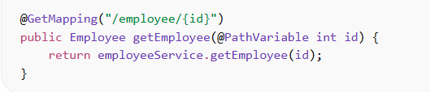
Spring automatically takes:
id = 10

How you debug in dev environment
How Debugging Works in IntelliJ — Step by Step
1️⃣ Add Breakpoint (Stop point in code) ⭐
Click left side of line number.
Red dot appears = breakpoint.
👉 Program will stop here during execution.
2️⃣ Run Application in Debug Mode
Click:
▶ Step Over (F8)
Go to next line.
Does NOT go inside method.
⬇ Step Into (F7)
Goes inside method to see internal logic.
▶ Resume (F9)
Continue program normally.

How you debug any production issue
Check Application Logs Using kubectl (kubectl (pronounced kube-control) is:
The command-line tool used to interact with a Kubernetes cluster.)
kubectl stands for Kubernetes Control.
Check running pods
kubectl get pods -n <namespace>

Check logs of pod
kubectl logs <pod-name> -n <namespace>

Stream logs (live debugging)
kubectl logs -f <pod-name> -n <namespace>

If multiple containers in pod
kubectl logs <pod-name> -c <container-name>

Altimetric
1.Find output:
public static void main(String[] args) {
String str1 = "May";
String str2 = new String("June");
String str3 = new String(str2.concat("July"));
str1.concat(str3);
str2 = str3;
System.out.println(str1); //May
System.out.println(str2); // JuneJuly
System.out.println(str3); //JuneJuly

String s3 = "JournalDev";
int start = 1;
int end = 5;
System.out.println(s3.substring(start, end));
}
Substring Part
String s3 = "JournalDev";
int start = 1;
int end = 5;
System.out.println(s3.substring(start, end));
Important Rule:
substring(start, end)
- start → inclusive
- end → exclusive
So:
Index: 0 1 2 3 4 5 6 7 8 9
Chars: J o u r n a l D e v
From index 1 to 5 (exclusive):
- 1 → o
- 2 → u
- 3 → r
- 4 → n
Output:
ourn

2. shift first two element to last ,
input = (1,2,3,4,5) o/p should be = (3,4,5,1,2)
using java 7
collections you can choose of your choice
but need to write the code with minimum time and space complexity

public class Main {
public static void main(String[] args) {
List<Integer> list=new ArrayList(Arrays.asList(1,2,3,4,5));
Collections.rotate(list,-2);
System.out.println(list);

}
}
3 . How spring boot works internally

4 . How dependencies get added to spring boot
In Spring Boot, dependencies are added using a build tool:
- ✅ Maven (pom.xml)
- ✅ Gradle (build.gradle)

5 . Difference between HashTable and Concurrent HashMap
✅ Hashtable
- Locks the entire map
- Every method is synchronized
public synchronized V put(K key, V value)
👉 Only one thread at a time can access the map.

✅ ConcurrentHashMap
- Locks only specific bucket (part of map)
- Uses CAS (Compare-And-Swap) and fine-grained locking
👉 Multiple threads can:
- Read simultaneously
- Write in different buckets simultaneously
✅ Much better performance.

Iterator Behavior
- Hashtable → Fail-fast
  - Throws ConcurrentModificationException
- ConcurrentHashMap → Fail-safe
  - Does NOT throw exception
  - Works on weakly consistent view

6 . Why hash set can not store duplicate element?
Because internally:
👉 HashSet uses HashMap
HashMap does this:
- Calls hashCode() on the key
- Finds bucket index
- Checks:
  - If bucket empty → insert
  - If bucket has element → compare using equals()
If equals() returns true
→ It treats it as duplicate
→ Does NOT insert again
So duplicate prevention depends on:
hashCode()
equals()

Why keys can not be duplicate?
Keys cannot be duplicate because Map is designed for fast lookup. The key acts as a unique identifier, and if the same key is inserted again, the value is replaced instead of creating a duplicate entry.

7 . notify() and notifyAll() belong to which class?
👉 They belong to:
java.lang.Object

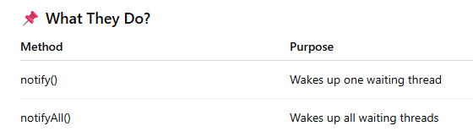

Concurrent HashMap
https://javabypatel.blogspot.com/2016/09/concurrenthashmap-interview-questions.html

Infosys
How you clone the code?
To clone a repository, I first copy the repository URL from GitHub, either using HTTPS or SSH.
Then I navigate to the desired local directory using Git Bash or terminal and run the command:
git clone <repository-url>
HTTPS = login-based access
SSH = key-based access
👉 SSH Keys (public + private)
Instead of typing username/password every time, your machine is already trusted.
So no login prompt.
What is git pull?
git pull origin develop pulls the latest code from develop branch
What is git rebase?
🌱 Imagine This Situation
You are working on a feature branch.
Meanwhile, your team is adding new code to the develop branch.
So now:
Your code is old 😅
Develop branch has new changes.

🔵 What You Want?
You want:
👉 Your feature to sit on top of the latest develop code
So that when you push, there is less chance of conflict.

🟣 What Rebase Does (Simple)
Rebase takes:
👉 Your work (code)
and puts it
👉 On top of the latest develop code
Git rebase is used to update a feature branch with the latest changes from develop
What is that http link in that git you clone?
Which Methodology you use in sprint ? (Agile)
We follow Agile Scrum methodology where work is divided into short sprints. Each sprint starts with planning, followed by daily standups to track progress, and ends with sprint review and retrospective for continuous improvement.
What is JSX
It allows us to write HTML inside JavaScript.
How JSX runs internally
Browsers only understand:
👉 HTML
👉 CSS
👉 JavaScript
So JSX must be converted into JavaScript.
1️⃣ Developer writes JSX
2️⃣ Babel compiles JSX → JavaScript using React.createElement()
3️⃣ JSX becomes React.createElement()
4️⃣ React builds Virtual DOM
5️⃣ Virtual DOM updates Real DOM

Can JSX be converted to typescript?
Yes ✅ — JSX can be converted to TypeScript.
JSX becomes TSX in TypeScript by adding static types for props, state, and functions while keeping the JSX syntax intact.
How TSX is converted to JSX
👉 TSX → TypeScript → JSX → Babel → React.createElement → JS
OR in simple terms:
TSX → (tsc) removes types → JSX stays
JSX → (Babel) converts → React.createElement()

Output
public class A {
public static void main(String[] args)
{
System.out.println('j' + 'a' + 'v' + 'a');
}
}
👉 Output = java ❌
But actual output is:
418
👉 Single quotes ' ' = char in Java
👉 Char behaves like a number (ASCII value)
So Java is doing addition, not string joining.
'j' + 'a' + 'v' + 'a'
= 106 + 97 + 118 + 97
= 418

String car, bus = "petrol";
what operation it is called
What it means
- car → declared but NOT initialized
- bus → declared and initialized with "petrol"
So internally it's like:
String car;
String bus = "petrol";
String car, bus = "petrol";
car = bus + "petrol";
System.out.println(car);
Step-by-step
- bus = "petrol"
- car = bus + "petrol"
So it becomes:
car = "petrol" + "petrol"
Output
petrolpetrol
Because in Java, + with String means concatenation (joining), not addition.

Interview Tip 🔥
+ behaves differently:
Type | Meaning
Number + Number | Addition
String + Anything | Concatenation

Zemoso Labs
What is Functional Interface?
What is Garbade collector?
What is HashMap?
What is Memory Leak?
What is Out of Memory Error?
What is Interceptor in spring Boot?
Interceptor is a component that lets you intercept HTTP request before and after they reach the Controller.
🟢 In Spring Boot Flow
Normal flow:
Client → Controller → Response
With Interceptor:
Client → 🛂 Interceptor → Controller → 🛂 Interceptor → Response
So it works:
Before request goes to controller
After controller sends response(Before response goes to the client)
👉 Think of it like a security guard or checkpoint between client request and your business logic.

🔹 Why we use Interceptor?
Used for:
✅ Authentication / Authorization
✅ Logging requests
✅ Measuring response time
✅ Modifying request / response
✅ Checking headers / tokens

Do you have knowledge on postHandle(), preHandle()?
Life Cycle Methods (Interview Important ⭐)

You create an interceptor by implementing:
HandlerInterceptor

It has 3 main methods:
1. preHandle()
➡ Runs before controller execution
Use cases:
Validate JWT token
Check user login
Start timer for performance tracking
Return:
true → Continue request
false → Stop request

2. postHandle()
➡ Runs after controller execution but before response is sent
Use cases:
Add extra response data
Logging business outcome

3. afterCompletion()
➡ Runs after complete request & response
Use cases:
Clean resources
Log final execution time
Exception tracking

What is MultipartResolver in Spring Boot?
👉 It helps Spring understand and process HTTP requests that contain files (like images, PDFs, etc.).

🔹 Problem It Solves
When a client uploads a file, the request comes as:
Content-Type: multipart/form-data
Normal request handling cannot read files directly ❌
So Spring uses MultipartResolver to:
✔ Detect multipart request
✔ Extract files
✔ Convert them into usable objects
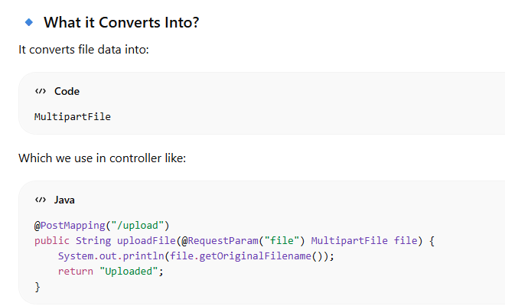
🔹 Flow
Client uploads file →
MultipartResolver detects request →
Converts into MultipartFile →
Controller processes it

Tell about Bean scope?
Program:
String str=”Character”;
Find 1st non-repeating character using java 8 stream

Character result = str.chars() // convert to IntStream
.mapToObj(c -> (char) c) // convert int → char
.collect(Collectors.groupingBy(
c -> c,
LinkedHashMap::new, // keeps order
Collectors.counting() // count frequency
))
.entrySet()
.stream()
.filter(entry -> entry.getValue() == 1) // find non-repeating
.map(Map.Entry::getKey)
.findFirst()
.orElse(null);
System.out.println(result);

1️⃣
str.chars()
👉 Converts the string into a stream of numbers (ASCII values)
Example:
"character" → 99, 104, 97, 114...

2️⃣
.mapToObj(c -> (char) c)
👉 Converts those ASCII numbers back into characters
Now stream becomes:
c, h, a, r, a, c, t, e, r

3️⃣
.collect(Collectors.groupingBy(
c -> c,
LinkedHashMap::new,
Collectors.counting()
))
👉 This step counts how many times each character appears
AND
👉 Uses LinkedHashMap to maintain original order
Result becomes:
Character | Count
c | 2
h | 1
a | 2
r | 2
t | 1
e | 1

4️⃣
.entrySet().stream()
👉 Convert the map into stream again
So we can process each entry
Now stream looks like:
(c=2), (h=1), (a=2), (r=2), (t=1), (e=1)

5️⃣
.filter(entry -> entry.getValue() == 1)
👉 Keep only characters that appear once
Now:
(h=1), (t=1), (e=1)

6️⃣
.map(Map.Entry::getKey)
👉 Extract only the character
Now:
h, t, e

7️⃣
.findFirst()
👉 Get the first non-repeating character
Result:
h

Wipro
@EnableAutoconfiguration how it works in spring boot
@Transactional -> @Transactional ensures that multiple database operations execute as a single unit and either all succeed or all rollback.
What is Dispatcher servlet -> 👉 DispatcherServlet is the front controller of Spring MVC
It handles all incoming HTTP requests.
It receives request → sends to correct controller → returns response

Distributed Transaction
How we do state management in React ->Redux and Context API we can use
Why we use useEffect hook ->to handle side effects like data fetching from API, setting up subscriptions and manually changing the DOM
Indexing in SQL
Output
class A{
m1(){print "A- m1"}
m2(){print "A-m2"}
}
class B extends A{
@Override
m2(){print "B-m2"}
m3(){print "B-m3"}
}
A ao = new B();
ao.m1(); //A m1
ao.m2(); //B m2
ao.m3();//Complie error

Program
String name="Ashmita";
int size=3;
Max count of vowel from substring

IBS Software
How to check logs in production
🌍 Production Setup
Your system is running in AWS EKS
Microservices:
- API Gateway
- Order Service
- Payment Service
- Inventory Service
- Notification Service
Each service runs as:
➡️ Kubernetes Pods

🚨 INCIDENT
User says:
👉 “Payment failed for my order”
How You start investigation.

🔵 STEP 1 — Open Grafana (Check System Health)
In production — you NEVER start with logs.
You open Grafana Dashboard.
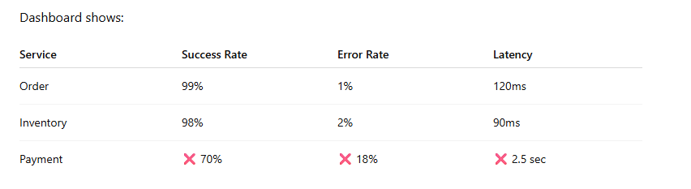
So now visually we understand:
👉 Something is wrong
👉 Payment service is unhealthy
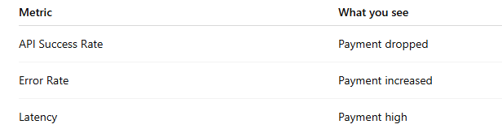
Grafana helps you identify:
❗ WHICH service is failing
Now move to logs.
🟣 STEP 2 — Centralised logging elastic search
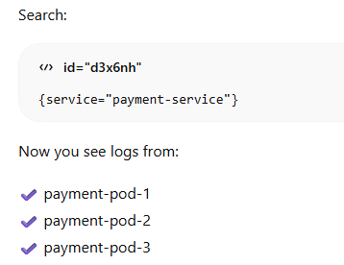
But still:
👉 Which request failed?

🔴 STEP 3 — Use Known Information
User doesn’t know traceId.
User gives:
👉 Order ID = 789
So you search:

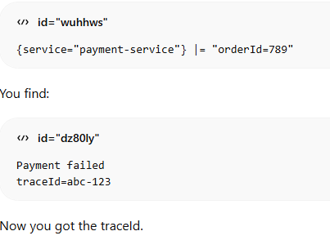

Each request have unique trace Id

You FOUND traceId
You did NOT start with it.

🟡 STEP 4 — Follow the Request Using TraceId
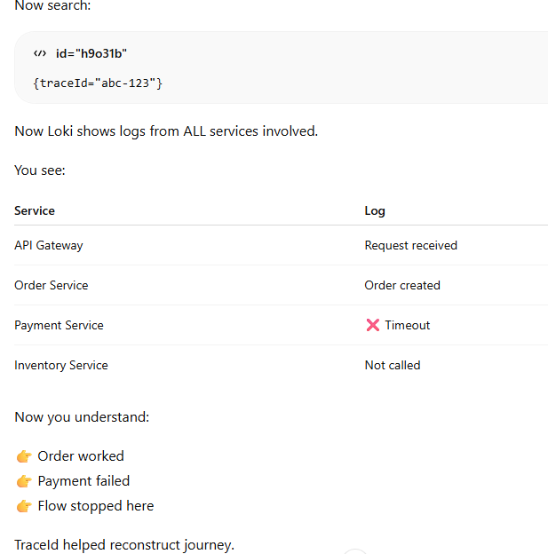
🟢 STEP 5 — Confirm Root Cause via Metrics
Go back to:
Grafana → Payment Service Metrics
Check:
Metric | Status
CPU | OK
Memory | OK
External API latency | ❌ High
So now:
👉 Payment service is waiting on bank API
👉 Bank API is slow
👉 Timeout occurred
Root cause identified.
🟠 STEP 6 — Fix in EKS
Options:
- Increase timeout
- Retry logic
- Scale pods
🔵 What is Grafana?
Grafana is a visualization & analysis tool
It does NOT store data.
Instead, it:
👉 Reads data from other systems
👉 Shows it in dashboards
Think of Grafana as:
🖥️ A control panel for your system

🧠 What Prometheus Actually Collects?
Prometheus collects metrics, not logs.
Example:
From Payment Service it collects:
Total requests
Error rate
Latency
CPU usage
Memory usage
DB connection usage

Then:
👉 Grafana shows it on dashboard

Grafana is NOT only for monitoring.
It is:
👉 Visualization + Monitoring + Alerting
So:
Tool | Role
Prometheus | Collects & stores metrics
Grafana | Displays & monitors metrics
🗣️ Answer
- In our microservices architecture deployed on Kubernetes, we implement application logging using SLF4J within each Spring Boot service.
- However, instead of directly jumping into logs during failures, we first rely on system metrics for early detection.
- Prometheus continuously collects service-level metrics such as API success rate, latency, and error rate through Actuator endpoints. These metrics are visualized in Grafana dashboards.
- For example, if we observe that the payment service shows increased latency and higher error rate in Grafana, it indicates that the service is unhealthy and requires deeper investigation.
- At this stage, we move to centralized logging implemented using Elasticsearch.
- All logs from distributed microservice pods are aggregated into Elasticsearch via a log collector. This allows us to search logs across services from a single place.
- When a user reports a failure, they typically provide a business identifier such as an orderId, not a technical identifier like traceId.
- So we first search the logs using orderId, which helps us identify the traceId associated with that request.
- Since a unique traceId is generated at the API Gateway and propagated across downstream services, we can then search using this traceId to reconstruct the complete request journey.
- This allows us to determine exactly where the request failed — for example, we may observe that the request reached the Payment service but timed out while calling an external dependency.
- This combined use of metrics for detection and logs with traceId for diagnosis enables efficient debugging in distributed production environments.

🚀 Final Short Closing Line
We use Prometheus and Grafana to detect issues and Elasticsearch with traceId-based log correlation to diagnose failures across microservices.

We query Elasticsearch using business identifiers such as orderId to locate the failed request and extract the associated traceId for further correlation across services.
Example — last 1 hour:
orderId:789 AND @timestamp:[now-1h TO now]
New features of Concurrent HashMap in java 8
🔥 1. No More Segments (Major Change)
❌ Before Java 8
ConcurrentHashMap had:
👉 16 Segments (default)
Each segment = one lock
So only 16 threads could write at a time.

✅ In Java 8
Segments are removed
Now locking happens at:
👉 Bucket level (Node level)

Before Java 8:
ConcurrentHashMap had:
Segment[16]
Each index = one Segment
Each Segment:
Had its own bucket array (HashEntry[])
Had its own lock
So:
If Segment 1 is locked
➡ Other 15 segments were still writable
So max parallel writes = 16

👉 There is NO segment at all in Java 8
Segments are gone completely ❌

2.From Java 8 Tree Structure
In ConcurrentHashMap, elements inside a bucket are initially stored using a linked list structure, where each node contains the hash, key, value, and a reference to the next node.
- If too many collisions happen in one bucket:
- If multiple keys have same hash value so it is stored in a same bucket
- If in the same bucket no of keys >8 or we can say If bucket size > 8
- Then elements are stored as tree Structure (👉 LinkedList → converts to → Red Black Tree)
What happen if access token get expired? How will the system understand that it got expired?
Refresh token does not detect access token expiry. The backend server identifies that the access token has expired when it receives a request and returns a 401 Unauthorized response. The client(browser) then sends the refresh token to a dedicated refresh endpoint, and if valid, the server generates and returns a new access token, allowing the user to continue without logging in again.
In payment service if money got deducted from customer account but merchant did not received the money . How this situation is being handled?
If I am having desktop and mobile application. While doing trade I can see updated portfolio in desktop application but it is not updated in mobile application why?
This happens due to session-level data sync differences between devices.

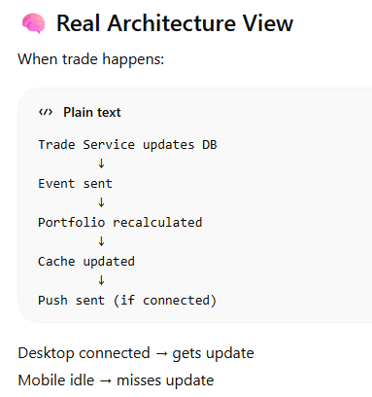
Coding
List<Integer> list= List.of(1,3,5,4,5,6)
Find duplicates with out using set and you can use stream java 8

String s="Ashmita Choudhury";
except A and y other characters need to be reversed

class Employee {
private int id;
private String name;
private String department;
private double salary;
private int age;
// constructor, getters, setters
}

List<Employee> employees = Arrays.asList(
new Employee(1, "Amit", "IT", 75000, 30),
new Employee(2, "Neha", "HR", 50000, 28),
new Employee(3, "Raj", "IT", 90000, 35),
new Employee(4, "Priya", "Finance", 60000, 40),
new Employee(5, "Karan", "IT", 75000, 25),
new Employee(6, "Sneha", "HR", 55000, 32)
);

1️⃣ Find all employees from "IT" department sorted by salary (descending).
2️⃣ Find the highest paid employee.
3️⃣ Group employees by department.
4️⃣ Find the average salary of each department.
5️⃣ Find the employee with second highest salary.

Dev ON (React Based)
Create react Form
After that Given one demo url need to fetch from data from there
Output
function outer(){
let a =10;
function inner(){
console.log(++a);
}
return inner;
}

var close = outer();
close();
close();
var closeOne = outer();
closeOne()

10
10
10

console.log(a); // undedefined
console.log(b); // error
sayHello();
var a = 10;
let b = 10;
function sayHello() {
console.log('Hello!'); //hello
}

What is TDZ? (Temporal Dead Zone)
👉 TDZ = Time between
Variable declaration
and
Variable initialization
during which the variable cannot be accessed

How to optimize React application

1. 🔹 Avoid Unnecessary Re-renders (MOST IMPORTANT)
React becomes slow mainly because of re-rendering again & again
Use React.memo
If component props are same → don’t re-render

Use useCallback
Avoid re-creating functions every render

Use useMemo
Avoid heavy recalculation

2🔹 Lazy Loading
Load component only when needed

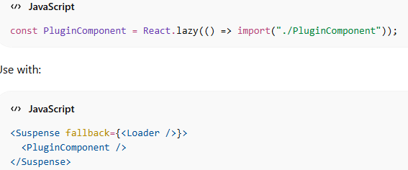

4. 🔹 Virtualization

When you use useMemo() Hook how react will understand when to memorize the calculation when not to?
useMemo works using:
👉 Dependency Array
useMemo(() => {
return calculation
}, [dependencies])
React does:
Step 1: First Render
Runs calculation
Stores:
✅ Result
✅ Dependencies

Step 2: Next Render
React checks:
➡️ Did dependencies change?
It compares:
Old deps vs New deps
Using shallow comparison.

Why do we need state in React
👉 State is used to store data that can change over time
React UI is based on data.
If data changes → UI should update.

Why we need state function can’t we change the variable directly
Because React doesn't track normal variables.
React doesn't know anything changed.
🧠 React Rendering Rule
React updates UI only when:
✔️ State changes
✔️ Props change
React Render rely on state changes otherwise react will not able to identify any change if we change the variables directly. Components will not get render
Changing a normal variable does not trigger React to re-render the component. React only tracks state and props. When we update state using setState, React knows the data has changed and re-renders the UI accordingly.

Health Edge
Difference between HashMap and Concurrent HashMap
HashMap
Your understanding is correct:
Read + Read in the same bucket: ✅ Can happen concurrently.
Read + Write in the same bucket: ❌ Not safely supported.
Write + Write in the same bucket: ❌ Not safely supported.
Write + Write in different buckets: ⚠️ Still not guaranteed to be thread-safe.
The last point is important. Even if two threads happen to modify different buckets, HashMap provides no thread-safety guarantee for concurrent modification of the map.
ConcurrentHashMap
Here also your understanding is mostly right:
Read + Read in same bucket: ✅ Concurrent.
Read + Write in same bucket: ✅ Supported safely.
Write + Write in different buckets: ✅ Can proceed concurrently.
Write + Write in same bucket: ⚠️ They are safely coordinated, not simply executed simultaneously.
This last distinction is very important.
✅ "When multiple threads try to update the same bucket, ConcurrentHashMap internally coordinates those updates using CAS and synchronization, so the updates are performed safely."

🔹 1. Thread Safety (Main Difference)
HashMap
Not thread-safe ❌
If multiple threads write → data corruption
Example problem:
Two threads updating → infinite loop or wrong data.

ConcurrentHashMap
Thread-safe ✅
Multiple threads can read & write safely
Used in:
Microservices
High concurrency systems
Caching
Real-time apps
👉 (Relevant to your Spring Boot microservices prep)

🔹 2. Locking Mechanism
HashMap
No locking → unsafe in concurrency.

ConcurrentHashMap
Uses segment-level / bucket-level locking
Meaning:
Instead of locking full map ❌
It locks only small part ✅
So:
➡️ Multiple writes can happen at same time
➡️ High performance in concurrent apps
Yes ✅
Inside different segments, multiple write operations CAN happen

🔹 3. Null Handling
Map | Null Key | Null Value
HashMap | ✅ 1 allowed | ✅ many
ConcurrentHashMap | ❌ Not allowed | ❌ Not allowed
Why?
Because in concurrency:
map.get(key)
If null returned ❌
We won’t know:
key absent OR
value null
So Java removed null support.

🔹 4. Iterator Behavior
HashMap → Fail Fast 🚨
If one thread modifies while another is iterating:
➡️ Throws ConcurrentModificationException

ConcurrentHashMap → Fail Safe ✅
Allows modification during iteration.
No exception 👍

🔹 5. Performance
Scenario | Best Choice
Single thread | HashMap
Multi-thread | ConcurrentHashMap

Distributed Transaction
How you did authentication in your project
Which scope you used
Which design pattern you used
How you give the product to the client -> In docker image
Which build you used? ->Maven
Which file you used jar or war? ->Jar file
Circuit Breaker
@Transactional
@Transactional when we use
Examples:
Use Case | Example
Money transfer | Debit + Credit
Order creation | Order + Payment + Inventory

Synchronized what it does
👉 It controls access to a resource when multiple threads are running.
It ensures:
✅ Only ONE thread can execute a block of code at a time
So it prevents:
❌ Data corruption
❌ Race conditions
🔹 Real-Life Example
Imagine:
Two threads updating bank balance 💰
Without synchronized:
Thread 1 → reads 1000
Thread 2 → reads 1000
Thread 1 → adds 500 → saves 1500
Thread 2 → adds 500 → saves 1500 ❌
Final should be 2000 😨

Different scopes in spring boot
Any major issue you faced during production recently
🔥 Major Production Issue – Duplicate Settlement
In our system, Trade Service sends a trade event to Kafka, and Settlement Service consumes it to update holdings and cash balance.
During a peak trading time in production, we noticed some trades were getting settled twice.
This happened because Settlement Service consumed the event, but due to a network issue, the service restarted before finishing the processing.
Since Kafka didn’t get the confirmation, it sent the same event again after restart.
As a result, the same trade was processed twice, which caused:
Incorrect holdings
Wrong cash balance
NAV calculation issues
Since this is a financial platform, this became a critical issue.

We solved this by making the Settlement Service idempotent.
This means:
➡️ Even if Kafka sends the same event again, it will be processed only once.
We did 3 simple things:
1️⃣ We added a unique trade ID in the settlement table.
So the same trade cannot be saved twice.
2️⃣ Before processing settlement, we added a check:
👉 If this trade is already settled → skip processing.
3️⃣ So even if Kafka re-sends the same message after restart,
Settlement Service safely ignores it.

You write junit test query
How kafka ensure safe message delivery -> aks=all explain
How consumer ensure that it received the message from kafka ->Explain auto commit offset
🔹 Scenario
You have:
One public method called from outside the class
One public method called internally (within same class)
Question:
👉 Where should we put @Transactional?

You should put @Transactional on the method that is:
👉 called from OUTSIDE the class
Spring uses Proxy mechanism to apply transaction.
Internal method calls within the same class bypass the proxy, so transactions will not be applied.

Program
Table 1
Customer Table
id
name

Table 2
Order table
id
amount
order date
customer id foreign Key

Query to fetch top 3 cx in last 6 months who made highest purchase

Write the same using stream

list of Objects of booked dates
each object have start date and end date
write am method that accept start date and end date
Check if we can book or not book the air bnb in p
canwebook()
method that accept start and end date and it will return
true or false

Quarks
Multi tenant data base
A Multi-tenant database is a design where one application serves multiple customers (tenants) but keeps their data logically separated.
Think of tenants = different companies or clients using the same software.
1️⃣ What is a Tenant?
A tenant is a separate customer or organization using the same application.
Example:
Tenant | Example Company
Tenant 1 | Company A
Tenant 2 | Company B
Tenant 3 | Company C
All use the same application, but their data must not mix.

Types of Multi-Tenant Database Designs
Shared Database, Shared Schema
One database, one schema, shared tables.
Each row contains a tenant_id column.
Example table:
tenant_id | user_id | name
1 | 101 | John
2 | 201 | David
Query example:
SELECT * FROM users WHERE tenant_id = 1;

Shared Database, Separate Schema
➡️ One database is used for all tenants
➡️ But each tenant has its own schema inside that database.
Example
Suppose 3 companies use your SaaS application.
Database: SaaS_DB
Inside the database:
SaaS_DB
├── tenant1_schema
│ ├── users
│ ├── orders
│
├── tenant2_schema
│ ├── users
│ ├── orders
│
├── tenant3_schema
├── users
├── orders
Each tenant has same table structure, but data is stored in its own schema.

Example queries:
Tenant1:
SELECT * FROM tenant1_schema.users;

Tenant2:
SELECT * FROM tenant2_schema.users;

Advantages
✅ Better data isolation than shared tables
Disadvantages
❌ Managing many schemas can become complex if tenants increase.

1️⃣ Order of Creation
Yes, generally the order is:
1. Create Database
2. Create Schema inside Database
3. Create Tables inside Schema
Example:
CREATE DATABASE company_db;
Create schema:
CREATE SCHEMA tcs_schema;
CREATE SCHEMA wipro_schema;
CREATE SCHEMA accenture_schema;
Create table inside schema:
CREATE TABLE tcs_schema.employees (
id INT,
name VARCHAR(50)
);

Separate Database per Tenant
Separate Database per Tenant means:
➡️ Each tenant (customer/company) has its own independent database.
➡️ The application is the same, but data is stored in different databases.

Example
Suppose your SaaS app has 3 companies:
- TCS
- Wipro
- Accenture
Architecture:
Application
|
|---- TCS → Database_TCS
|
|---- Wipro → Database_Wipro
|
|---- Accenture → Database_Accenture
Each database has its own tables.
Example:
Database_TCS
├── employees
├── orders
Database_Wipro
├── employees
├── orders
Database_Accenture
├── employees
├── orders
Even if table names are same, databases are completely separate.

Implementation

Identify Tenant from Request
Tenant is usually passed via:
- Header
- Subdomain
- JWT token
Example request:
GET /employees
Header:
X-Tenant-ID: TCS

Store Tenant in Thread Context ->This stores the current tenant per request.

Interceptor to Capture Tenant ->Now every request knows which tenant is calling.

Create Routing DataSource
Spring provides:
AbstractRoutingDataSource
This dynamically decides which database to use.

Configure Multiple Databases

Schema:
schema is a logical container inside a database that holds tables, views, procedures, etc.
Think of it like a folder in a computer.
Database → Schema → Tables

Example
Suppose we have a database called:
CompanyDB
Inside the database we can have schemas:
CompanyDB
├── hr_schema
│ ├── employees (table)
│ ├── salary (table)
│
├── sales_schema
├── customers (table)
├── orders (table)

Coding
Write a program in react using Hooks
There is a List of Integer with duplicate nos. Find the no.s that is repeated exactly twice and return the List

Tao Digital
Take Integer array
Find 2nd largest value

public class SecondLargest {

public static void main(String[] args) {
int[] arr = {10, 5, 20, 8, 25, 3};

int largest = Integer.MIN_VALUE;
int secondLargest = Integer.MIN_VALUE;

for (int num : arr) {

if (num > largest) {
secondLargest = largest;
largest = num;
}
else if (num > secondLargest && num != largest) {
secondLargest = num;
}
}

System.out.println("Second Largest: " + secondLargest);
}
}

React life cycle
1️⃣ Mounting → Component is created and added to the DOM
2️⃣ Updating → Component re-renders when state or props change
3️⃣ Unmounting → Component is removed from the DOM

React components have three lifecycle phases: mounting, updating, and unmounting. In class components, these are handled using lifecycle methods like componentDidMount, componentDidUpdate, and componentWillUnmount. In functional components, lifecycle behavior is implemented using React Hooks, mainly the useEffect hook.

Difference between Where And Having Clause

Why you use Foreign Key

Wissen Technology
Code:
Find the output:
public class TestCollection {

public static void main(String[] args)

{

List<Integer> al = new ArrayList<>();

al.add(1);

al.add(2);

al.add(3);

al.add(4);

al.add(5);

System.out.println(al);

Iterator<Integer> itr = al.iterator();

itr = al.iterator();

while (itr.hasNext()) {

if (itr.next() == 3) {

al.remove(3);

}

}

System.out.println(al);

}

}

Find the Output

Code:

abstract class A
{
protected abstract void firstMethod();
public void secondMethod()
{
System.out.println("SECOND");
firstMethod();
}
}
abstract class B extends A
{
@Override
void firstMethod()
{
System.out.println("FIRST");
thirdMethod();
}
protected abstract void thirdMethod();
}
class C extends B
{
@Override
void thirdMethod()
{
System.out.println("THIRD");
}
}
public class MainClass
{
public static void main(String[] args)
{
C c = new C();
c.firstMethod();
c.secondMethod();
c.thirdMethod();

}

}

Consider a database schema for an e-commerce platform with the following tables.
Write a SQL query to find the top 3 best-selling product categories
(based on the total quantity of products sold), along with the total quantity
of products sold in each category.

Table Name: Products

product_id name category price

1 Laptop Electronics 800

2 Smartphone Electronics 500

3 Headphones Electronics 100

4 T-shirt Clothing 20

5 Jeans Clothing 50

6 Shoes Footwear 80

7 Watch Accessories 150

8 Sunglasses Accessories 70

9 Backpack Accessories 40

10 Book Books 15

Table Name: Orders

order_id customer_id order_date

1 101 2023-01-05

2 102 2023-01-10

3 103 2023-01-15

4 104 2023-01-20

5 105 2023-01-25

6 101 2023-02-05

7 102 2023-02-10

8 103 2023-02-15

9 104 2023-02-20

10 105 2023-02-25

Table Name: OrderDetails

order_detail_id order_id product_id quantity

1 1 1 1

2 1 3 2

3 2 2 3

4 3 4 2

5 3 6 1

6 4 7 1

7 5 8 2

8 5 9 1

9 6 10 3

10 7 5 2

Expected Output:

product_category total_quantity_sold

Electronics 6

Accessories 4

Clothing 4

SELECT p.category AS product_category,SUM(od.quantity)AS
total_product_sold FROM OrderDetails od JOIN
Products p ON od.product_id=p.product_id
GROUP BY p.category ORDER BY total_products_sold DESC LIMIT 3;

Internal working of React JS

1 Developer writes JSX
↓
2 Babel converts JSX → JS
↓
3 React.createElement() creates React elements
↓
4 Virtual DOM created
↓
5 Render to Real DOM
↓
6 State/Props change
↓
7 New Virtual DOM created
↓
8 Diffing (compare old vs new)
↓
9 Reconciliation
↓
10 Update only changed DOM nodes

React converts JSX to JavaScript, creates a Virtual DOM representation of the UI, and when state or props change it creates a new Virtual DOM. React then compares the old and new Virtual DOM using a diffing algorithm and updates only the changed parts of the real DOM through reconciliation.

Redux

Redux is a state management library used to manage application data in one central place.
It helps multiple components share and update the same data easily.
Main Concepts in Redux
1️⃣ Store
The store is the central place where the application state is stored.
Example state:
{
user: { name: "Abhroy" },
cart: ["item1", "item2"],
isLoggedIn: true
}
There is only one store in Redux.

2️⃣ Action
Actions describe what happened.
Example:
{
type: "ADD_TO_CART",
payload: "Laptop"
}
Action tells Redux:
"Add this item to the cart."

3️⃣ Reducer
Reducer is a function that updates the state based on the action.
Example:
function cartReducer(state = [], action) {
switch (action.type) {
case "ADD_TO_CART":
return [...state, action.payload];
default:
return state;
}
}
Reducer rules:
- Must be pure function
- Cannot modify original state
- Always returns new state

4️⃣ Dispatch
Dispatch is used to send action to Redux.
Example:
dispatch({
type: "ADD_TO_CART",
payload: "Laptop"
})

Complete Redux Flow
User clicks button
↓
Component dispatches action
↓
Redux reducer receives action
↓
Reducer updates state
↓
Store updates
↓
React re-renders UI

EPAM
What is actuator
Spring Boot Actuator is a monitoring and management tool for a Spring Boot application.
👉 In simple words:
Actuator helps you check the health and internal information of your running application.
It exposes special endpoints (URLs) that show information about your application.
Maven Dependency
<dependency>
<groupId>org.springframework.boot</groupId>
<artifactId>spring-boot-starter-actuator</artifactId>
</dependency>
Common Actuator Endpoints
Endpoint | Purpose
/actuator/health | Shows application health
/actuator/info | Shows app information
/actuator/metrics | Shows performance metrics
/actuator/beans | Lists all Spring beans
/actuator/env | Shows environment properties
/actuator/loggers | Change logging level at runtime
1️⃣ Why do we use Actuator?
When an application runs in production, we need to know:
- Is the application running or down?
- Is the database connected?
- How much memory / CPU is used?
- What beans are loaded?
- What HTTP requests are happening?
Instead of logging everything manually, Actuator gives ready-made endpoints to see this information.
4️⃣ When do we use Actuator?
We use Actuator mainly in production environments.
Typical cases:
1️⃣ Microservices monitoring
2️⃣ Kubernetes health checks (liveness / readiness)
3️⃣ Performance monitoring
4️⃣ Debugging production issues
Example tools:
- Prometheus
- Grafana
- Datadog
These tools collect Actuator metrics.
Difference between Future and Completable Future
👉 Future is an interface
we submit the task to the executor service, then executor service takes the task and runs it in a separate thread and it returns a Future object so that the result is stored and can be used. We can get the result or use the result later when needed.
When we call get() method in Future it blocks the main thread
CompletableFuture is used to run tasks asynchronously and process the result later without blocking the main thread.
(It was introduced in Java 8.)
CompletableFuture is a class
CompletableFuture implements interfaces:
- Future<T>
We can use CompletableFuture by using supplyAsync() method and get the result using thenAccept() method.
Both Future and CompletableFuture are used for asynchronous programming in Java.

Zemoso Labs
Zomato/ Swiggy design pattern
Find length of substring with out repeating characters
Why java is Platform Independent?
Java is called platform independent because a Java program can run on any operating system without changing the code.
Java Source Code (.java)
↓
Compiled by Java Compiler (javac)
↓
Bytecode (.class)
↓
JVM
↓3
Machine Code (OS specific)
Steps:
- Developer writes Java code.
- Java compiler converts it into bytecode.
- Bytecode runs on the JVM.
- JVM converts bytecode to machine code for that operating system.
Difference between Abstraction and Polymorphism?
Polymorphism (Focus: Different ways to do same thing)
Polymorphism means one interface, multiple implementations.
Abstraction (Focus: What to do)
Abstraction hides implementation details and shows only essential features.

Why is immutability used?
ArrayList vs LinkedList in Java
Why array list is not optimise for insert and delete
What is the Contract Between equals() and hashCode()
The Contract Rules
Rule 1
If two objects are equal using equals(), then their hashCode must be the same.
Rule 2
If two objects have the same hashCode, they may or may not be equal.
Rule 3
If two objects are not equal, their hashCodes can be different (but not mandatory).

Altimetric
Two sum program
Compltebalefuture
Why do we use kafka
Design pattern which one you know

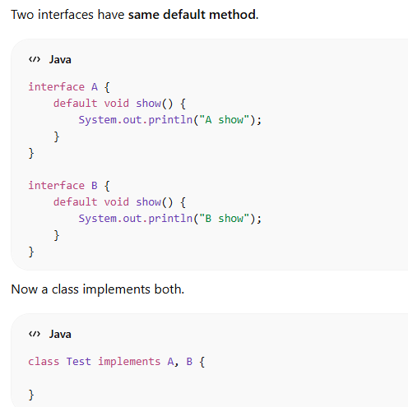
How will you call the methods inside Test Class? (Syntax)

Tech Mahindra
What are Profiles?
Profiles allow you to maintain different configurations for different environments, such as:
- Development (dev)
- Testing (test)
- Staging (staging)
- Production (prod)
Instead of changing code, you simply activate a different profile.

What are components in react?
If any screen gives 404 error, how will you check or will you handle it?
✅ What is 404?
404 = Resource not found (API or page doesn’t exist)

🔎 How I check:
Verify URL is correct
Check backend API mapping (@RequestMapping, @GetMapping)
Ensure correct HTTP method (GET/POST)
Confirm service is running
If frontend → check route configuration

Difference between Collection and Collections?
Difference between Multithreading and multi task?

Mphasis
1️⃣ Problem Scenario
You have two services:
Service A → depends on → Service B
Example:
Service A = Order Service
Service B = Payment Service
Flow:
Client → Service A → Service B → Database
But suddenly Service B goes down.
How will you ensure that service A should Still respond
1️⃣ Circuit Breaker
3️⃣ Retry
4️⃣ Fallback Response
You can say:
If Service A depends on Service B and Service B is down, we should implement resilience patterns like Circuit Breaker, Retry, Timeout, and Fallback.
Circuit breaker prevents continuous calls to a failing service and returns a fallback response so Service A remains available.
We can implement this using Resilience4j in Spring Boot.
Service B might be down due to high traffic, database failure, deployment issues, network problems, or resource exhaustion.

Optimistic and Pessimistic Locking

Debouncing is a technique used to prevent a function from being executed multiple times in a short period.
It ensures the function runs only after a certain delay once the user stops triggering the event.

1️⃣ Simple Idea
When events happen very frequently, like:
- typing in a search box
- clicking a button repeatedly
- resizing a window
Debouncing waits for a pause before executing the function.

Accolite

Difference between static and default method?

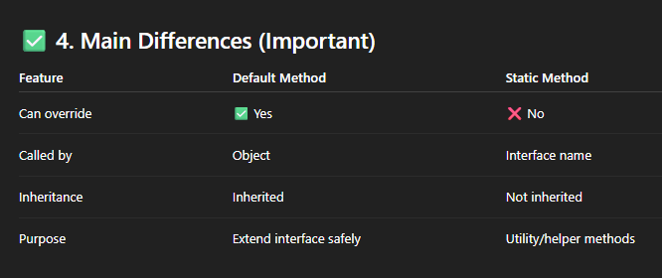

1. Key Idea
👉 Explain:
Instance methods → belong to objects → can be inherited
Static methods → belong to class → not part of object → not inherited in real sense

✅ 2. Why Not Inherited?
👉 Say this clearly:
“Static methods are resolved at compile time, not at runtime. So Java does not allow overriding, and inheritance is mainly useful for overriding behavior.”

✅ 3. Important Concept: Overriding vs Hiding
👉 This is where you can impress interviewer 🔥
👉 Say:
“Static methods are not overridden, they are hidden.”

What is Synchronised hash Map?
A synchronized HashMap is a thread-safe version of HashMap where only one thread can access it at a time.”

✅ 2. Why Do We Need It?
👉 Explain:
“Normal HashMap is not thread-safe. If multiple threads modify it at the same time, it can cause data inconsistency.”

✅ 3. How to Create Synchronized HashMap
👉 Say:
“We can make a HashMap synchronized using Collections.synchronizedMap().”
🔹 Example:
import java.util.*;
Map<Integer, String> map = new HashMap<>();
Map<Integer, String> syncMap = Collections.synchronizedMap(map);

Difference betn HashMap and Synchronised HashMap?
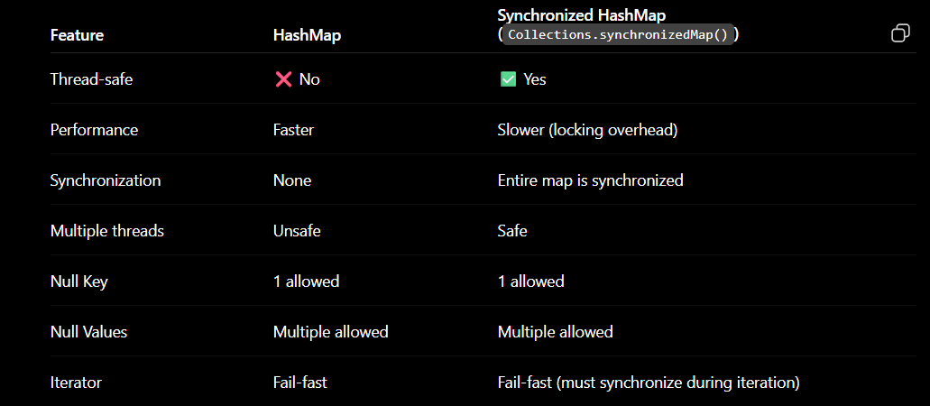
Difference betn Concurrent HashMap and Synchronised HashMap?
✅ 1. Start with Simple Definition
👉 You can say:
“A synchronized HashMap and ConcurrentHashMap are both thread-safe, but they handle concurrency differently.”

✅ 2. Key Difference (Main Point 🔥)
👉 Say this clearly:
“Synchronized HashMap locks the entire map, while ConcurrentHashMap allows multiple threads to work on different parts of the map at the same time.

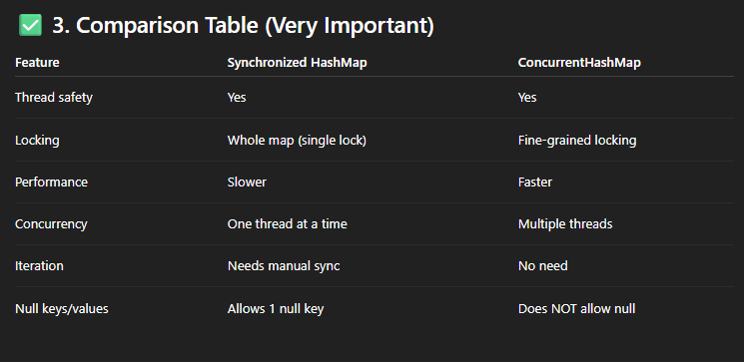

“Synchronized HashMap is fail-fast, while ConcurrentHashMap is fail-safe.”

PWC
Find Output8
public class ExceptionExample {
public static void main(String[] args) {
try {
int a = 2 / 0;
} catch (ArrayIndexOutOfBoundsException e) {
System.out.println(" array index out of bounds.");
} catch (Exception e) {
System.out.println(e);
}catch (ArithmeticException e) {
System.out.println("ArithmeticException ");
}
}
}

Write code

int[] arr={95,120,85,105,98,102,150};
print the numbers closest to 100

Wissen Technology
Class Cat {
str name,
str type
}
var cat1 = new Cat('Jack', 'Animal')
map. Put(cat1, 50)
cat1.setName('Jill')
SOP(map.get(cat1))

✅ Final Answer (what interviewer expects)
System.out.println(map.get(cat1));
👉 Output:
null

🎯 Why?
- When you do:
map.put(cat1, 50);
👉 HashMap stores the key based on hashCode() of "Jack"
- Then you change:
cat1.setName("Jill");
👉 Now hashCode() changes (if based on name)
- When you call:
map.get(cat1);
👉 HashMap searches in a different bucket

🔥 One-line interview explanation
"Output is null because modifying the key changes its hashCode, so HashMap cannot locate the original entry."

Mother Earth has provided us with all the resources.
The world is full of wonders.
Find the start index of the word 'world'.

DELOITE
Find Palindrome
public static void main(String[] args){
String str="madam";
String reversed="";
for(int i=str.length()-1;i>=0;i--){
reversed+=str.charAt(i);
}
if(str.equals(reversed)){
System.out.println("Palindrome");
}
else{
System.out.println("Not Palindrom");
}
}

int arr[]={6,3,5,6,1}
store integers that is not repeated in any collection
during iteration if any integer is repeated entire element will be removed

output

3,5,1

public static void main(String args[]){
int arr[]={6,3,5,6,1};
Set<Integer>set=new LinkedHashSet<>();
for(int num:arr){
set.add(num);
}
System.out.println(set);
}

Wipro
Difference bent permanent generation and meta space
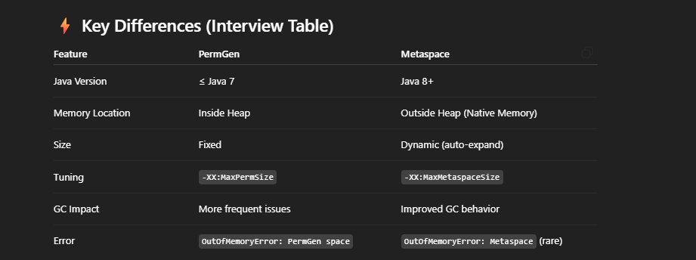
Where static variables are stored?
Method area
The Method Area is a part of JVM memory that stores:
- Class metadata
- Method definitions
- Static variables
- Constant pool
Before Java 8
Implemented using PermGen (Permanent Generation)
👉 Inside Heap memory
Java 8 and later
Implemented using Metaspace
👉 Stored in Native memory (outside heap)
✅ So:
Method Area = Metaspace (outside heap)

Code:
String inputString = "Java Concept Of The Day";
extract each word and find out the frequency of word using stream

ExecutorService is a Java framework used to manage and execute threads efficiently. Instead of creating threads manually, you submit tasks to an ExecutorService, and it uses a pool of reusable threads to execute them.

Difference between Executor, ExecutorService and executes()

